**Table of Contents Page No.**

**Chapter I: Introduction**………………………………………….… **11**

1.1 Problem Definition

1.2 Motivation

1.3 Objectives

**Chapter II: Literature Review / Related Work**…………….......... **15**

**2.1. Recognition of Hand Landmarks**……….………………...… **16**

2.1.1. Palm Detection Model

2.1.2. Hand Landmark Model

2.1.3. Datasets

2.1.4. Capturing Images for Dataset

**2.2. Detection of Face Landmarks**…………...……………..…… **20**

2.2.1. Face landmark detection mechanism

2.2.2. Implementing the face landmark detection

2.2.3. Detection and Extraction

**Chapter III: System Analysis & Design**………………….........… **23**

**3.1. Hand Detection Analysis**……………..……..……………… **24**

3.1.1. Introduction

3.1.2. Image Processing

3.1.3. Hand Detection Approaches

3.1.3.1. Colour

3.1.3.2. Shape of Hand

3.1.3.3. Learning Detectors from Pixel Values

3.1.3.3. 3D Model-Based Detection

3.1.3.4. Motion

3.1.4. Approach for Hand Detection in this Research

3.1.4.1. Skin Detection

**3.2. Facial Recognition Analysis**……………..……..………..... **34**

3.2.1. Introduction

3.2.2. Detection and Localization

3.2.3. Viola-Jones

3.2.4. You Only Look Once (YOLO)

3.2.5. Faster R-CNN

**Chapter IV.I: System Implementation**……………..……..….… **41**

**4.1. Finger Counting Application Module**……………..…….… **42**

4.1.1. Introduction

4.1.2. Fact Finding

4.1.3. Facts Pre-Processing

4.1.4. Result Analysis & I/O Specification

**4.2. Virtual Mouse Application Module**……………..………… **47**

4.2.1. Introduction

4.2.2. The Camera Used in the AI Virtual Mouse System

4.2.3. Capturing the Video and Processing

4.2.4. Rectangular Region for Moving through the Window

4.2.5. Detecting Finger Up & Performing Mouse Function

4.2.6. For the Mouse to Perform Left Button Click

4.2.7. For No Action to be Performed on the Screen

4.2.8. Result Analysis & I/O Specification

**4.3. Volume Control Application Module**……………..……….. **52**

4.3.1. Introduction

4.3.2. Working Principal of Volume Control

4.3.3. Result Analysis & I/O Specification

**4.4. Gender Detection Application Module**……………..……… **54**

4.4.1. Introduction

4.4.2. Gender Prediction

4.4.3. Gender Network

4.4.4. Model Training

4.4.5. Result Analysis & I/O Specification

**4.5. Emotions Detection Application Module**……………..…… **60**

4.5.1. Introduction

4.5.2. Working Principal of Emotions Detection

4.5.3. Emotion Detection

4.5.4. Emotion Detection Training

4.5.5. Result Analysis & I/O Specification

**Chapter IV.II: Hardware & Software Requirements**…………. **66**

5.1 Hardware Requirements

5.2 Software Requirements

**Chapter IV.III: Application Tools**……………..……………..… **68**

6.1 Python

6.2. Python GUI – Tkinter

6.3. MediaPipe

6.3.1. Hand Configuration

6.3.2. Face Configuration

6.4. OpenCV

6.5. NumPy

6.6. AutoPy

6.7. TensorFlow Lite

6.8. PyCaw

6.9. Keras

6.10. Haarcascades Model

**Chapter IV.IV Algorithm Used**……………..………………..…. **81**

**7. Face Recognition Algorithm**……………..……………….…. **82**

7.1. Local Binary Patterns Histograms (LBPH)

7.1.1 Introduction

7.1.2 Proposed Algorithm

**8. Hand Gesture Algorithm**……………..…………………..…. **87**

8.1. SVM & HOG

8.1.1. Introduction

8.1.2. Proposed Algorithm

8.1.3. Overview of Techniques

*8.1.3.1. Detecting Object*

*8.1.3.2. Tracking Object*

*8.1.3.3. Object Classification Technique*

8.1.4. Real-Time Object Tracking Technique

**Chapter IV.V: Snapshots**……………..…………………….….... **93**

9.1. Application GUI Snapshot

9.2. Finger Counting Application

9.3. Virtual Mouse Application

9.4. Volume Control Application

9.5. Gender Detection Application

9.6. Emotions Detection Application

**Chapter V: Advantages & Disadvantages**……………..……… **99**

10.1 Advantages for Hand Gesturing

10.2 Disadvantages for Hand Gesturing

10.3 Advantages for Face Detection

10.4 Disadvantages for Face Detection

**Chapter VI: Conclusion**……………..………………………….. **101**

**Chapter VII: Future Scope**……………..………………………. **103**

**Chapter VIII: References**……………..……………………....… **105**

**List of Figures**

Figure 2.1.2.1 Hand Landmark …………………………………… **18**

Figure 2.1.3.1 Counting Fingers …………………………………... **19**

Figure 2.2.1.1 Face Detection Key Points ………………………... **21**

Figure 2.2.2.1 Face Landmark …………………………………...... **22**

Figure 3.1.2.1 Image Processing …………………………………... **27**

Figure 3.1.3.1 Hand Detection Approach …………………………. **31**

Figure 3.1.3.1.1 HSV Model …………………………………........... **33**

Figure 3.2.3.1 Detection Window …………………………………. **36**

Figure 3.2.4.1 Image to Grid Cells ………………………………... **38**

Figure 3.2.5.1 R-CNN Network …………………………………... **39**

Figure 4.1.1.1 Hand Gesture Pre-Processing ……………………... **44**

Figure 4.1.4.1 Count 1 ………………………………….................. **45**

Figure 4.1.4.2 Count 2 ……………………………………………... **45**

Figure 4.1.4.3 Count 3 ……………………………………………... **46**

Figure 4.1.4.4 Count 4 …………………………………………….. **46**

Figure 4.1.4.5 Count 5 …………………………………………….. **47**

Figure 4.2.8.1 Moving Cursor …………………………………..... **50**

Figure 4.2.8.2 Mouse Click ………………………………….......... **51**

Figure 4.2.8.3 No Mouse Operation ……………………………... **51**

Figure 4.3.3.1 Volume Increase …………………………………. **53**

Figure 4.3.3.2 Volume Decrease ……………………………….... **54**

Figure 4.4.5.1 Gender Detection ………………………………… **59**

Figure 4.5.3.1 Learning Phase ………………………………... **62**

Figure 4.5.4.1 Emotion Detection Training …………………… **63**

Figure 4.5.5.1 Emotion Detection …………………………….. **65**

Figure 7.1.2.1 LBP Operation ………………………………… **83**

Figure 7.1.2.2 LBP Procedure ………………………………… **85**

Figure 7.1.2.3 Extracting the Histograms …………………….. **85**

Figure 8.1.2.1 Hand Gesture Proposed ……………………….. **88**

Figure 8.1.2.2 ROI Model …….……………………………….. **89**

**List of Tables**

Table 2.1.3.1 Dataset ……………………………………………….…… **19**

Table 4.4.3.1 Gender Network (A & B) ...…………………………….…… **55**

Table 4.4.3.2 Gender Validation (A & B) ..…………………………….….. **56**

Table 4.4.4.1 Gender Training .……………………………………….…… **58**

Table 4.4.4.2 Validation Training ...……………………………………..…. **59**

**List of Snapshots**

Snapshot 9.1.1 CSGD Application ……………………………….…… **87**

Snapshot 9.1.2 CSGD Application ……………………………….…… **87**

Snapshot 9.1.3 CSGD Application ……………………………….…… **88**

Snapshot 9.2.1 Finger Counting Application …………………….…… **88**

Snapshot 9.3.1 Mouse Control ……………………..…………….…… **89**

Snapshot 9.4.1 Volume Control System ………………...……….…… **89**

Snapshot 9.4.2 Volume Control System …………………...…….…… **90**

Snapshot 9.5.1 Gender Detection …………………………….….…… **90**

Snapshot 9.6.1 Emotions Detection ……………………..……….…… **91**

**List of Abbreviations**

* Artificial Intelligence (AI)
* Application Programming Interface (API)
* Convolutional Neural Network (CNN)
* Central Processing Unit (CPU)
* Deep Learning (DL)
* Facial Recognition (FR)
* Graphics Processing Unit (GPU)
* Human computer interaction (HCI)
* Histogram of Oriented Gradients (HOG)
* Hue, Saturation, Value (HSV)
* [Local Binary Patterns Histograms (LBPH)](https://en.wikipedia.org/wiki/Local_binary_patterns)
* Machine Learning (ML)
* Region Based Convolutional Neural Networks (R-CNN)
* Red Blue and Green (RBG)
* Regions of Interest (ROI)
* Region proposal network (RPN)
* Scale-Invariant feature transform (SIFT)
* Support Vector Machine (SVM)
* You only look once (YOLO)

**Abstract**

Efficient and accurate gesture and gender detection has been an important topic in advancement of computer vision systems. The project aim is to recognize the human gestures using mathematical algorithm, also to detect emotions and gender through the given data set. Gesture recognition is one of the essential techniques to build user-friendly interfaces. And on the other hand, automatic gender recognition has now pertinent to an extension of its usage in various software and hardware, particularly because of the growth of online social networking websites and social media. Gesture recognition contains unsolved problems for the last two decades, such as low accuracy or low speed, and despite many proposed methods, no perfect result has been found to explain these unsolved problems. In this thesis, we suggest a machine learning approach to translating sign gesture language into text. This paper describes how hand gestures are trained to perform certain actions like switching pages, scrolling up or down in a page using machine learning models and also, we have explored that by doing learn and classification method and with the utilization of deep convolutional neural networks technique, a satisfied growth in performance can be achieved on such gender classification task.

**Keywords:** Sign Gesture recognition, Gender recognition, Deep Learning, Machine Learning, Neural Network, Datasets, Image Processing, Conventional neural network.

CHAPTER I

**INTRODUCTION**

**Chapter I: Introduction**

* 1. **Problem Definition**

In this paper to build the project we have used OpenCV, TensorFlow Lite Keras for gender and emotion recognition and on other hand we used OpenCV, NumPy, MediaPipe and Math libraries to progress the gesture control system. And to make this application user friendly we shall be using Tkinter framework to combine features and build the application graphical user interface. Gender Recognition was started with the problem in psychophysical studies to classify gender from human face; it concentrates on the e orts of perceiving human visual processing and recognizing relevant features that can be used to distinguish between female and male individuals. The Deep Conventional Neural Network(D-CNN) technique used in face recognition, involving face dependent gender recognition, age-based recognition, comprises the phases of accepting the image as input and then transforming input images for further processing, dimension reduction, feature extraction, feature procurement, and classification, in this sequence. Detecting the real-time emotion of the person with a camera input is one of the advanced features in the machine learning process. The detection of emotion of a person using a camera is useful for various research and analytics purposes. The detection of emotion is made by using the machine learning concept. You can use the trained dataset to detect the emotion of the human being. For detecting the different emotions, first, you need to train those different emotions, or you can use a dataset already available on the internet. In this article, we will discuss creating a Python program to detect the real-time emotion of a human being using the camera. Gesture recognition is an active research field in Human-Computer Interaction technology. It has many applications in virtual environment control and sign language translation, robot control, music creation or media control. In this machine learning project on Hand Gesture Recognition, we are going to make a real-time Hand Gesture Control Recognizer. OpenCV is a real-time Computer vision and image-processing framework built on C/C++. But we’ll use it on python via the OpenCV-python package.

* 1. **Motivation**

The motivation for gesture recognition researchers is to develop a system which can detect the gestures and these gestures are widely used for conveying the information or to control the devices. Camera based solutions for gesture recognition has been widely used in numerous applications and capability to communicate through Human Computer Interaction. A new device called Leap Motion Controller is discussed which provides the complete information of hands helps to track hand movements and gestures through API (Application Programming Interface). An idea of real time hand gesture recognition process through this device is explained along with insight of existing machine learning models. Finally, an attempt is made to explain the complexities with the device and the models along with its features. Although humans possess well-developed face processing expertise, face processing is nevertheless subject to a variety of biases. Perhaps the best known of these biases is the Cross-Race Effect--the tendency to have more accurate recognition for same-race than cross-race faces. The current work reviews the evidence for and provides a critical review of theories of the Cross-Race Effect, including perceptual expertise and social cognitive accounts of the bias. The authors conclude that recent hybrid models of the Cross-Race Effect, which combine elements of both perceptual expertise and social cognitive frameworks, provide an opportunity for theoretical synthesis and advancement not afforded by independent expertise or social cognitive models. Finally, the authors suggest future research directions intended to further develop a comprehensive and integrative understanding of biases in face recognition.

* 1. **Objectives**

Gesture recognition helps computers to understand human body language. This helps to build a more potent link between humans and machines, rather than just the basic text user interfaces or graphical user interfaces (GUIs). In this project for gesture recognition, the human body's motions are read by computer camera. The computer then makes use of this data as input to handle applications. The objective of this project is to develop an interface which will capture human face and hand gesture dynamically and will control the volume level, mouse events, sign of hand, gender and emotions detection. The objective is to provide a fast and accurate detection of face and hand gestures in different lighting conditions and in cluttered background. Machine learning methods were used to detect gestures and translate them into text. The objective of emotion recognition is identifying emotions of a human. The emotion can be captured either from face or from verbal communication. In this work we focus on identifying human emotion from facial expressions. The paramount objective of the paper is to build a gender detector that can approximately guess the gender of the face of an individual in a picture using Deep Learning on the audience dataset. The thesis, therefore, presents these steps, beginning by presenting some popular algorithms used previously to implement facial recognition systems alongside datasets used to build and evaluate these algorithms. Next step is to research the detection and alignment processes, to understand the mechanism behind them and how they can apply them in the system.

CHAPTER II

**Literature Review / Related work**

**Chapter II: Literature Review / Related Work**

**2.1. Recognition of Hand Landmarks**

The ability to perceive the shape and motion of hands can be a vital component in improving the user experience across a variety of technological domains and platforms. For example, it can form the basis for sign language understanding and hand gesture control, and can also enable the overlay of digital content and information on top of the physical world in augmented reality. While coming naturally to people, robust real-time hand perception is a decidedly challenging computer vision task, as hands often occlude themselves or each other (e.g., finger/palm occlusions and handshakes) and lack high contrast patterns. MediaPipe Hands is a high-fidelity hand and finger tracking solution. It employs machine learning (ML) to infer 21 3D landmarks of a hand from just a single frame. Whereas current state-of-the-art approaches rely primarily on powerful desktop environments for inference, our method achieves real-time performance on a mobile phone, and even scales to multiple hands. We hope that providing this hand perception functionality to the wider research and development community will result in an emergence of creative use cases, stimulating new applications and new research avenues.

### 2.1.1. Palm Detection Model

To detect initial hand locations, we designed a [single-shot detector](https://arxiv.org/abs/1512.02325) model optimized for mobile real-time uses in a manner similar to the face detection model in [MediaPipe Face Mesh](https://google.github.io/mediapipe/solutions/face_mesh.html). Detecting hands is a decidedly complex task: our [lite model](https://github.com/google/mediapipe/tree/master/mediapipe/modules/palm_detection/palm_detection_lite.tflite) and [full model](https://github.com/google/mediapipe/tree/master/mediapipe/modules/palm_detection/palm_detection_full.tflite) have to work across a variety of hand sizes with a large scale span (~20x) relative to the image frame and be able to detect occluded and self-occluded hands. Whereas faces have high contrast patterns, e.g., in the eye and mouth region, the lack of such features in hands makes it comparatively difficult to detect them reliably from their visual features alone. Instead, providing additional context, like arm, body, or person features, aids accurate hand localization.

Our method addresses the above challenges using different strategies. First, we train a palm detector instead of a hand detector, since estimating bounding boxes of rigid objects like palms and fists is significantly simpler than detecting hands with articulated fingers. In addition, as palms are smaller objects, the non-maximum suppression algorithm works well even for two-hand self-occlusion cases, like handshakes. Moreover, palms can be modelled using square bounding boxes (anchors in ML terminology) ignoring other aspect ratios, and therefore reducing the number of anchors by a factor of 3-5. Second, an encoder-decoder feature extractor is used for bigger scene context awareness even for small objects (similar to the RetinaNet approach). Lastly, we minimize the focal loss during training to support a large number of anchors resulting from the high scale variance.

With the above techniques, we achieve an average precision of 95.7% in palm detection. Using a regular cross entropy loss and no decoder gives a baseline of just 86.22%.

### 2.1.2. Hand Landmark Model

After the palm detection over the whole image our subsequent hand landmark [model](https://github.com/google/mediapipe/tree/master/mediapipe/modules/hand_landmark/hand_landmark_full.tflite) performs precise key point localization of 21 3D hand-knuckle coordinates inside the detected hand regions via regression, that is direct coordinate prediction. The model learns a consistent internal hand pose representation and is robust even to partially visible hands and self-occlusions.

To obtain ground truth data, we have manually annotated ~30K real-world images with 21 3D coordinates, as shown below (we take Z-value from image depth map, if it exists per corresponding coordinate). To better cover the possible hand poses and provide additional supervision on the nature of hand geometry, we also render a high-quality synthetic hand model over various backgrounds and map it to the corresponding 3D coordinates.

### 

**Figure 2.1.2.1 Hand Landmark**

### 2.1.3. Datasets

A dataset for American Sign Language was created as there is no standard dataset available for all countries/sub continents. In the present scenario, the requirement for large vocabulary dataset is in demand. Moreover, the existing dataset is incomplete and additional hand gestures had to be included. In future, this research will help other researchers to develop their own dataset based on their requirements. This dataset is a collection of 36 characters which contains A to Z alphabets and 0 to 9 numerical digits. Right hand was used to capture 1000 images for specific alphabets and numbers. Code was implemented to flip the images from the 14 rights to the left-hand image. The height and width ratios vary significantly but average approximately 50x50 pixels. The dataset contains over 72,000 images in grayscale. Additionally, people can add their images to this dataset. Figure 2.1.3.1 shows images of 1 to 5 counting fingers. Table describes the dataset properties.

****

**Figure 2.1.3.1 Counting Fingers**

|  |  |
| --- | --- |
| **Property** | **Description** |
| Numbers | 0 to 9 |
| Colour | Gray Scale |
| Dimensions | 50x50 |
| Height | 50 pixels |
| Width | 50 pixels |
| File type | JPEG |

**Table 2.1.3.1 Dataset**

### 2.1.4. Capturing Images for Dataset

To detect hand gesture using skin colour, there are different approaches including skin colour-based methods. In this thesis, after detecting and subtracting the face and other background, skin recognition and a contour comparison algorithm were used to search for the hand and discard other background colour objects for every frame captured from a webcam or video file. First, we need to extract and store the hand contour and skin color which is used to compare with the frame in order to detect the hand. After detecting the skin area for each frame captured, the contours of the detected areas were compared with the saved hand histogram template contours to remove other skin like objects existing in the image. If the contour comparison of the spotted skin area complies with any one of the saved hand histogram contours, then it captured hand gesture only.

**2.2. Detection of Face Landmarks**

Face landmark detection is a computer vision task where we want to detect and track key points from a human face. This task applies to many problems.

For example, we can use the key points for detecting a human’s head pose position and rotation. With that, we can track whether a driver is paying attention or not. Also, we can use the key points for applying an augmented reality easier. And there are so many solutions that we can generate based on this task.

Thankfully, we don’t have to understand the concepts of face landmark detection in detail. We can use the prebuilt library like dlib, OpenCV, and mediapipe. In this article, I will show you how to implement face landmark detection with dlib and mediapipe.

### 2.2.1. Face landmark detection mechanism

Mediapipe is a tool for implementing ML-based computer vision solutions. The tool is created by Google. This tool contains varieties computer vision solutions, such as face detection, pose estimation, object detection, and many more. The advantage of this library is that you can apply the solutions on many platforms, such as web, mobile, PC, and many more. I’ve already explained in the previous section to you how to implement face landmark detection using dlib. Now let’s implement the face landmark detection using Mediapipe. The library uses the BlazeFace model for detecting face landmarks. BlazeFace is a deep learning model that is already optimized for low spec devices like smartphones. Therefore, we can use the model in real-time. BlazeFace contains two main steps. First, the model detects one or more faces on an image. Second, the image detects around 468 face keypoints by using regression. Different from the dlib library, this model detects 3D coordinates. Those x and y coordinates are normalized from the image scale. The z coordinate is retrieved by taking the relative calculation between the screen and the model x coordinates.



**Figure 2.2.1.1 Face Detection Key Points**

### 2.2.2. Implementing the face landmark detection

In general, the pipeline for implementing face landmark detection is the same as the dlib library. It starts from importing libraries, initializing objects, detect face and its landmarks, and done.

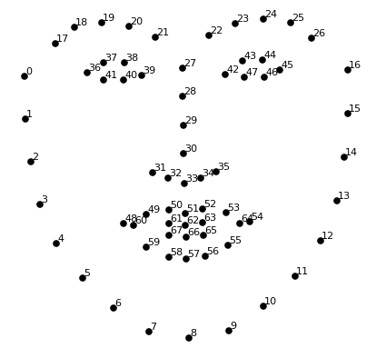

**Figure 2.2.2.1 Face Landmark**

### 2.2.3. Detection and Extraction

Face detection and localisation are a long-standing challenge in computer vision. In the previous chapter, we investigated and sought into face detection through multiple techniques beginning with machine learning algorithms to the deep learning methods. The human face has a unique structure, and it's back to local facial parts like eyes, nose, and mouth, and these features assist in localising and detecting faces under unrestrained condition.

CHAPTER III

**System Analysis & Design**

**Chapter III: System Analysis & Design**

**3.1. Hand Detection Analysis**

### 3.1.1. Introduction

Dataset creation plays an important role in the object detection. To analyse and extract relevant data about an object of interest from an image, one needs first to detect the object in the image. Hand posture detection refers to finding the place and size of hand within a sequence of images. Nowadays it is a very popular computer vision problem and has numerous applications, such as gesture recognition, sign language recognition, computer graphics games, and human-computer interaction (HCI). Skin colour is an important property to detect hand and tracking. However, Colour image has a different problem of removing other objects with similar colours such as a face and a human arm. To solve this problem, we introduce a new method to detect hand postures only using face detection and subtraction, skin detection, and hand postures contour detection and comparison algorithm. The face was removed because the skin detection will detect the face and the face’s contours are very similar to the first-hand gesture contours. The area of interest in captured, and another same skin colour is removed from an area of interest. After removing an unwanted area of the face, the skin area was detected using the hue, saturation, value (HSV) colour model since it has real-time performance and it is strong against alternations, scaling and lighting conditions.

### 3.1.2. Image Processing

Computer vision is an important topic in image processing. Investigation on the subject has been to approach the problem from bottom-up perception for many years. This was the beforementioned effort to validate directions guiding the vision of living organisms. This method was actually very successful in certain environments.

A general explanation of computer vision in image processing can be briefly explained in the following steps:

* **Thresholding on Image:**

Thresholding is the process of forcing a certain or all the pixel values either to zero or to the maximum possible value. Various thresholding techniques are available to process images. Thresholding can be performed either with a grayscale image or a colour image. Binary thresholding makes pixel values either to zero or 255 based on the threshold value provided. The pixel values below the threshold value are set to zero, and the pixel values above the threshold value are set to 255. We can recall that 0 refers to black and 255 refers to white in a grayscale image. Thus, a grayscale image applied with binary thresholding will become a black-and-white-only image. On the other hand, a colour image applied with binary threshold values will only have black, blue, green, red or any combination of the latter three colours. For instance, combination B+G+R gives white colour, and R+G gives yellow colour. Inverse binary thresholding is the inverted process of binary thresholding. The pixel values above the threshold are set to zero and the pixel values below the threshold are set to 255. The resulting image will become a black-and-white-only image if the input is a grayscale image. In truncated thresholding, the pixel values below the threshold are left unaltered, and all other values are set to the threshold value. Threshold-to-zero is the thresholding process of setting the pixel values below the threshold to zero while the pixel values above the threshold are left unaltered. Threshold-to-zero-inverse is the thresholding process of setting the pixel values above the threshold to zero while the pixel values below the threshold are left unaltered.

* **Image Smoothing:**

Image smoothing is an important image processing technique that performs blurring and noise filtering in an image. It finds applications in pre-processing and postprocessing of deep learning models. In general, smoothing is performed by a 2D kernel of a specific size on each channel of the image. The kernel average of neighbourhoods yields the resulting image. The famous smoothing algorithms in use are Blur, Gaussian Blur, Median Blur and Bilateral Filter.

* **Image Gradients:**

Image gradients are the rate of change of pixel values in either x or y direction or in both x and y directions. It helps identify the sudden changes in pixel values. In other words, it helps detect the edges. If the gradient is applied in x-direction, vertical edges are detected. If the gradient is applied in y-direction, horizontal edges are detected.

* **Canny Edge Detection:**

Canny Edge Detection is a powerful edge detection algorithm that performs Gaussian noise filtering, Sobel based horizontal and vertical edges detection, non-maximum suppression to remove unwanted edge points and hysteresis thresholding with two limiting thresholds to have thin and strong edges.

* **Image Contours:**

Image contours are the continuous shape outlines present in an image. OpenCV detects the contours present in an image and collects its coordinates as a list. The collected contours can be drawn over the original image back.



**Figure 3.1.2.1 Image Processing**

### 3.1.3. Hand Detection Approaches

There are different approaches for hand detection. They have been introduced in the literature to employs different visual features and in many cases their combination. These are different approaches such as motion, skin colour, shape, and 3D models of hands. Hand detection methods were discussed in and will be discussed later in this chapter.

### 3.1.3.1. Colour

Skin colour detection has been used in many hand gesture recognition projects. The main objective of giving a model of skin colour is the choice of the colour space to be utilized. Different colour spaces have been introduced such as RGB, normalized RGB, HSV, YCrCb, and YUV. Colour spaces that effectively divide the chromaticity from the luminance parts of colour are typically regarded as preferable as I did in my approach by removing the Value (V) section in the HSV model. This is because of employing chromaticity-dependent mechanisms of colour only.

Generally, skin colour detection can be disordered by background objects; they have skin colour distribution like human skin colour. Some projects have been done on this problem by using background subtraction. On the contrary, it was expected that unwanted background subtraction normally depends on the camera system that does not move with respect to a fixed background. Another solution has been applied with dynamic modification of background compensation techniques.

### 3.1.3.2. Shape of Hand

Shape property is defined in terms of the set of contours that describe the boundary of a hand. More details can be acquired by reducing the contours of objects in the frame. If the contour is perfectly detected, it provides a good presentation of the hand gesture which is indirectly related to a viewpoint, skin colour, and lighting. Typically, contour extraction based on edge recognition uses many edges fitting to the hand image area but also to distinct background objects.

Accordingly, sophisticated post-processing techniques are needed to develop the presentation of this method such as our approach in by combining skin colour detection with contour detection and comparison after face subtraction. A second method that has been used in fingertip finding is pattern matching. Patterns can be images of fingertips or fingers or generic 3D cylindrical models. These pattern matching methods can be upgraded by using extra image features such as contours.

### 3.1.3.3. Learning Detectors from Pixel Values

The present technique uses a machine learning method, which has shown remarkably strong results in face recognition and good results in hand recognition. In, an object recognition method was proposed in which a weak classifier may be a simple finder that uses basic image block differences efficiently calculated using an integral image. On the other hand, this technique may provide an unnecessary number of weak classifiers. The AdaBoost technique has a drawback because it does not consider the removal of chosen weak classifiers that no longer take part in the recognition procedure. The strong classifier is composed of a set of weak learners with associated weights. Each weak learner uses a single image feature to produce a hypothesis. The object detection system uses simple features to build weak learners. Viola and Jones suggest the use of features rather than pixel values directly. Also, there is some problem to distinguish the hand using the Viola-Jones method related to rotation and cluttered background.

### 3.1.3.3. 3D Model-Based Detection

One major advantage of a 3D model-Based method is that it can allow for view-independent detection. The used 3D models must have enough degrees of freedom to adapt to the dimensions of the hand that exist in an image. Different mock-ups use different image features to build feature-model communications. Line and point features are applied in kinematic hand models for recovering angles created at the links of the hand. The hand gesture is then estimated based on the relations between the 3D model and the observed image features.

### 3.1.3.4. Motion

Motion is a dynamic feature employed by some procedures for hand detection. Motion-based recognition requires a highly controlled arrangement, and it adopts that the only movement in the image resulted from hand motion. In the case of fixed cameras, the issue of movement assessment is solved with background maintenance and successive removal. This explanation is employed for recognizing the hand from other skin- coloured objects, and for testing with lighting conditions resulting from coloured lights. The difference in pixel strength between two consecutive frames is close to zero for the background pixels. Motion objects are placed by selecting and maintaining a suitable threshold.

### 3.1.4. Approach for Hand Detection in this Research

An integrated system is proposed for detection, segmentation, and tracking of the hand in a gesture recognition system using a single webcam. My proposed hand posture finding algorithm has real-time performance and is strong against rotations, scaling, cluttered background, and lighting conditions. Detecting the human hand in a plain background will boost the performance of hand gesture recognition systems. In this method, the speed and result of recognition will be the same for any frame size and the system will also be robust against a plain background as only the hand posture area is detected. A smaller image size that holds the detected hand posture area is suitable for training image size of a training stage of the classification. To detect the hand gesture in the image, a four-phase system was designed as shown in Figure 3.1.3.1. First, load hand contour template which will be used to compare and detect hand skin area pattern from webcam using the contours comparison algorithm. Then we will open a camera which has a square box to capture hand gesture. The hand must be placed fully within the square box. The skin colour locus (captured skin contour template) for the image is removed from the user’s skin colour after face deletion. In the last step, the hand gesture is spotted by removing false positive skin pixels and identifying hand gesture and other real skin colour regions using contour matching with the loaded hand gesture pattern contours.

Template contours Comparison with Skin Area

Skin detection

Area

Capturing

images from webcam

Loading hand gesture template

contours

**Figure 3.1.3.1 Hand Detection Approach**

### 3.1.4.1. Skin Detection

Skin detection is a useful approach for many computer vision applications such as face recognition, tracking and facial expression, abstraction, or hand tracking and gesture recognition. There are recognized procedures for skin colour modelling and recognition that will allow differentiating between the skin and non-skin pixels based on their colour. To get a suitable distinction between skin and non-skin areas, a colour transformation is needed to separate luminance from chrominance. The input images normally are in Colour format (RBG), which has the drawback of having components dependent on the lighting situations. The misunderstanding between the skin and non-skin pixels can be decreased using colour space transformation. There are different approaches to detection of skin colour components in other colour spaces, such as HSV, YCbCr, TSL or YIQ to provide better results in parameter recovery under changes in lighting conditions. Researches have shown that skin colours of individuals cluster tightly in the colour space for all people from different societies, for example, colour appearances in human faces and hands vary more in intensity than in chrominance. Thus, take away the intensity V of the original colour space and working in the chromatic colour space (H, S) provides invariance against illumination situations. In this research, hue, saturation, value (HSV) colour model was used, since it has been shown to be one of the most adapted to skin-colour detection. HSV model is easier to represent a colour than RGB colour space. It is also well-matched with human colour perception. Also, it has real-time execution and it is more robust in cases of rotations, scaling, cluttered background, and changes in lighting condition. The projected hand gesture detection algorithm is real-time and sturdy against the mentioned previous changes. The other skin like objects existing in the image are removed from contour comparison with the loaded hand posture prototype contours. The HSV colour space is gained by a nonlinear transformation of the essential RGB colour space. The conversion between RGB and HSV was described in. Hue (H) is a section that characterizes a pure colour such as pure yellow, orange or red, whereas saturation (S) provides a measure of the degree to which a pure colour diluted by white light. Value (V) attempts to represent brightness along the Gray axis such as white to black, but since intensity is subjective, it is thus difficult to measure. According to and Figure 3.1.3.1.1, Hue is estimated in HSV colour space by a position with red starting at 0, Green at 120 and Blue at 240 degrees. The black mark in the diagram at the lower left on the screen determines the hue angle. Saturation is a ratio that ranges between 0.0 along the middle line of the cone (the V axis) to 1 on the edge of the cone. Value ranges, string from 0.0 (dark) to 1.0 (bright).



**Figure 3.1.3.1.1 HSV Model**

According to the HSV model can be resulting from the non-linear transformation from an RGB model according to the calculations in equations.



Once image converts to HSV then we use a histogram of an image containing our object of interest. After that, Gaussian kernel is applied to remove noise from Image. As per a classification point of view, skin-colour detection is divided into two class problem: skin-pixel vs non-skin-pixel classification. Currently, different known classification approaches exist such as thresholding, Gaussian classifier, and multilayer perceptron. In this research, thresholding technique is used that allows getting a good result for higher computation speed when compared with other techniques, given our real-time requirements. In image processing, Gaussian blur is used to reduce noise and reduce details. Thresholding classification is used to find the values between two components H and S in the HSV model as the Value (V) component was removed. Usually, a pixel can be observed as being a skin-pixel when the following threshold values are satisfied: 0° < H < 20° and 75° < S < 190°. In the last step, skin detected object is stored into pickle object, called contour template. Contour template is a curve joining all continuous points having the same intensity. As we stated that contours are the boundary of a shape with the same intensity. It stores the values of x and y coordinates of boundary of the shape, to store all coordinate values.

**3.2. Facial Recognition Analysis**

### 3.2.1. Introduction

The important steps to recognize an object in an image, which are Detection and Localization, and alignment. These three steps it's compulsory in object recognition algorithms to extract the relevant feature's information from an input image.

### 3.2.2. Detection and Localization

Face detection is the first stage of a face recognition system since the system should first locate the face then recognise it. The face is just like instances of objects, the system seeks to locate and categorize them from a specific denomination such as (people, buildings, number, etc.) in an image, this technique is performed by discriminating the patterns formed by the objects from the other patterns and oriented the dimensions of each object. The skin detection factor has been significantly influential in face detection algorithms to decrease the area of search feature detection, and computational process, a variety of human skin colours are spanned in a pre-specified scale, and each pixel within that domain is known as skin pixels. Moreover, locating that domain itself is a difficult task as the range of skin varies by ethnicity and race.

### 3.2.3. Viola-Jones

Paul Viola and Michael Jones (2001, 1) in their paper " Rapid Object Detection using a Boosted Cascade of Simple Features ", provided a new competitive object detection framework that the primary purpose is to detect faces in real-time, this framework has a very low false-positive rate and the high true-positive rate which makes the algorithm rapid and robust. The author will briefly explain the three main features of this framework: The first feature is called an integral image, and it is considered that all human faces have the same features, such as the nose bridge region is whiter than the eyes region, and so on. The computed process for an integral image will be using a few operations per pixel. The second feature is to describe the methods to construct a classifier by using the AdaBoost training algorithm that helps to find small critical visible features from a wide range of possible features. The third feature is the process of combining the cascading classifiers, which neglect the background regions so that more computation can be performed on face-like regions. The object detection process in this algorithm classifies images in accordance with the value of simple features, and the reason to use features instead of the pixel value return to the features can act to encode the domain knowledge that is difficult to learn using small dataset. Moreover, the feature-based system runs rapidly and robustly than a pixel-based system. In figure 3.2.1.1, four examples demonstrate the rectangle features relative to the detection window, Figures 3.2.1.1 A and B have the same size and shape, to detect a specific feature the algorithm will subtract the sum of the pixel of the white rectangle from the sum of the pixel of the grey rectangle, both rectangles should move horizontally or vertically. Figure 3.2.1.1 C shows three rectangles which will subtract the sum of the pixels in the centre rectangle from the sum of the pixels of the sides’ rectangles.

### 

**Figure 3.2.3.1 Detection Window**

### 3.2.4. You Only Look Once (YOLO)

According to Joseph Redmon, Santosh Divvala, Ross Girshick, and Ali Farhadi (2016, 1), Yolo, or (You Only Look Once) takes one feed forward propagation across the network to make predictions. YOLO detects the objects in an arbitrary image magnificently unlike region-based and parts-based methods since YOLO used to see the full representation during the training and testing phase, it gets every information about the entire image and the objects. The algorithm has good detection accuracy under different complicated conditions, like an illumination environment, and noise while satisfying the real-time performance. Redmon J. et al. (2016,2) “YOLO sees the entire image during training and test time, so it implicitly encodes contextual information about classes as well as their appearance”. It is developed based on a regression problem; it predicts classes and bounding boxes for an image by applying the algorithm one time on the image. The algorithm will split the given image to grid cells S \* S, as shown in Figure 3.2.4.1, each grid cell will have a prediction bounding box, the degree of confidence for each prediction, and a class of probabilities; most of the boxes have a low predicted result, so we can avoid unnecessary bound boxes or objects detected by setting a threshold. The prediction bounding box can be portrayed as (width, height, centre, class); in addition, the model will calculate the value of prediction by using this formula:

𝑐𝑜𝑛𝑓𝑖𝑑𝑒𝑛𝑐𝑒 = 𝑃𝑟(𝑜𝑏𝑗𝑒𝑐𝑡) ∗ 𝐼𝑂𝑈𝑝𝑟𝑒𝑑𝑡𝑟𝑢𝑡ℎ



**Figure 3.2.4.1 Image to Grid Cells**

### 3.2.5. Faster R-CNN

The R\_CNN is slow, and each extracted region needs to operate the entire forward CNN calculation, and the network coefficients will not update during the regression. Faster R-CNN will normalise the input image and any extracted boxes around features from the first layers and added to the final convolution layer directly. This step will increase the computing speed since there is no prolonged need to store any information for an extracted feature in the first layers, which makes training faster. Ross Girshick (2016, 1441) proposed the faster R-CNN algorithm to improve the R-CNN speed and accuracy. Faster R-CNN has many advantages, such as GPU will not be filled with extracted data for the feature caching; the training set is one-step using a multi-task loss will update the network layers. The comprehensive performance has been improved particularly in terms of detection speed since it creates a convolution network to generate the proposed box and shares the convolution network with the object detection network which reduces the number of proposed frames approximately to more than half compared to R-CNN. The architecture of Faster R-CNN is composed of the region proposal network (RPN) and Fast R-CNN. RPN used to reduce the computational process by scanning rapidly and effectively the spots in an image to evaluate the needs for more computational in specific spots using a convolutional neural network. Fast R-CNN has a deeper architecture than RPN; it consists of a convolutional neural network, a region of interest pooling layer (ROI), fully connected layers, and finally has two sections for classification and regression (Figure 3.2.5.1).



**Figure 3.2.5.1 R-CNN Network**

According to BIN LIU, Wencang ZHAO and Qiaoqiao SUN (2017, 6234) Faster R-CNN used RPN (Region Proposal Networks) instead of Selective Search methods used in Fast R-CNN. The Faster R-CNN framework can be classified into four steps:

* **Convolution Layers:**

Through the first step, the algorithm through the ConvNet layers, ReLU activation function, and pooling layers will extract the image feature maps.

* **Region Proposal Network (RPN):**

RPN is a fully convolutional network that predicts the boundaries and numbers of objects at each position. RPN shares image convolutional feature maps with a detection network, thus enabling nearly complementary region proposals.

* **ROI Pooling:**

ROI gathers both of input image features and the proposals for these features and produces fixed-size feature maps by applying max-pooling on the inputs. In the pooling layer, the output and the input channels are identical.

* **Classification:**

Classification layers calculate the proposal class and compare it to the proposal feature maps to get the final exact position of the checkbox. Facial landmarks localization is an uncomplicated detection problem and intends to ascertain the image size and position of faces in still and video images. Localization is a crucial stage in the face recognition process. In face recognition and face tracking in real-time, we can use the location found by the face detector. The area used to align the face, but if the detection steps are not robust and accurate enough, the new face landmarks, like a nose, between the eyebrows, and mouth are required.

CHAPTER IV.I

**System Implementation**

**Chapter IV.I: System Implementation**

**4.1. Finger Counting Application Module**

### 4.1.1. Introduction

A Hand Gesture Recognition System recognizes the Shapes and or orientation depending on implementation to task the system into performing some job. Gestures is a form of non-verbal information. A person can make numerous gestures at a time. As humans through vision perceive human gestures and for computer we need a camera, it is a subject of great interest for computer vision researchers such as performing an action based on gestures of the person.

Python has libraries that will help us develop our project. We will need OpenCv and MediaPipe. We will later look at why and how we will use these two libraries.

We will also need a Python IDE. We will use VSCode community edition as it is freely available on the internet.

This tutorial will discuss how to hand track using python with the help of a MediaPipe library. We will also learn how to implement computer vision in our project using OpenCv.

Lastly, we will learn how to combine MediaPipe, OpenCv, and Python to create a program that will count the number of fingers in an input image. A person using Windows or Linux can follow through.

### 4.1.2. Fact Finding

The first move is to capture the copy from camera and to define a area of Interest in the surround, it is important as the image can contain a lot of variables and these variables can result in unwanted results and the data that needs to be processed is cheap to a large amount. To capture the image a web-camera is used that continuously captures surrounds and is used to get the raw data for giving out. The input picture we have here is uint8. The Procured image is RGB and must be processed before that is before-processed before the workings are divided and response is made.

### 4.1.3. Facts Pre-Processing

Pre-processing method can be completed 2-steps process:

* Divided
* Morphological clarifying

First Process is the Divided in process. It is done to change over grey-scale picture into the binary picture so we can have just two Area of Interest in photo.

That is, one will be hand and another one is related.

There are two main approaches to segmentation:

1. Pixel-based or local methods having: -
2. Edge detection
3. Boundary detection.
4. Region-based approach: -
5. The region merging
6. The region splitting
7. Threshold method

 

**Figure 4.1.1.1 Hand Gesture Pre-Processing**

### 4.1.4. Result Analysis & I/O Specification

* In this application, we first look into hand tracking and then we will use the hand landmarks to count the fingers.
* The main objective is to analysis sign language, translation for disable and deaf people.
* Ease of use is the foremost concern.

This application can perform hand task, such as:

* Detect hand landmarks.
* Count the fingers and display on the screen.

Our system tracks just one hand to recognize its gestures.

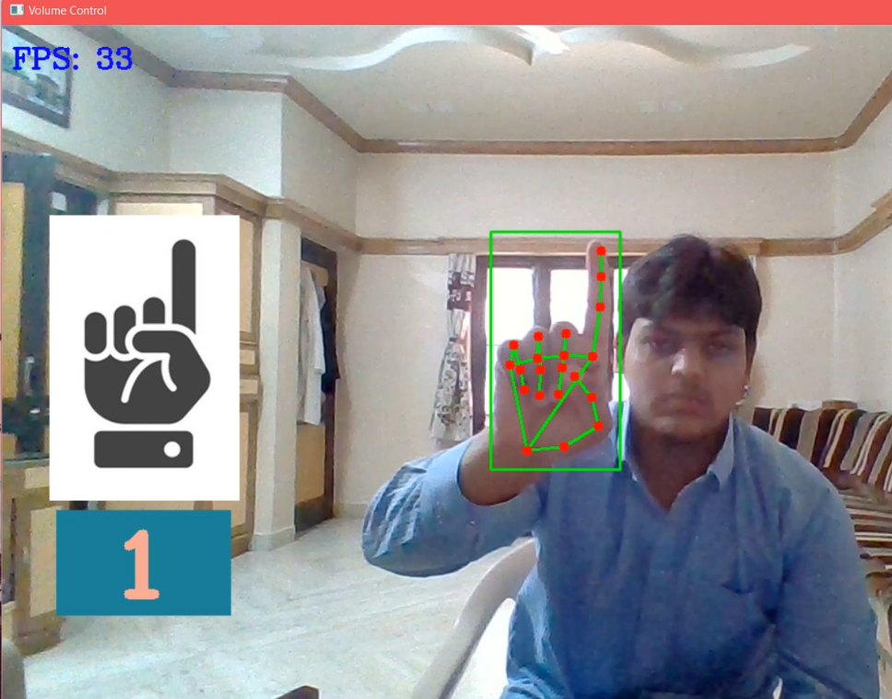

**Figure 4.1.4.1 Count 1**

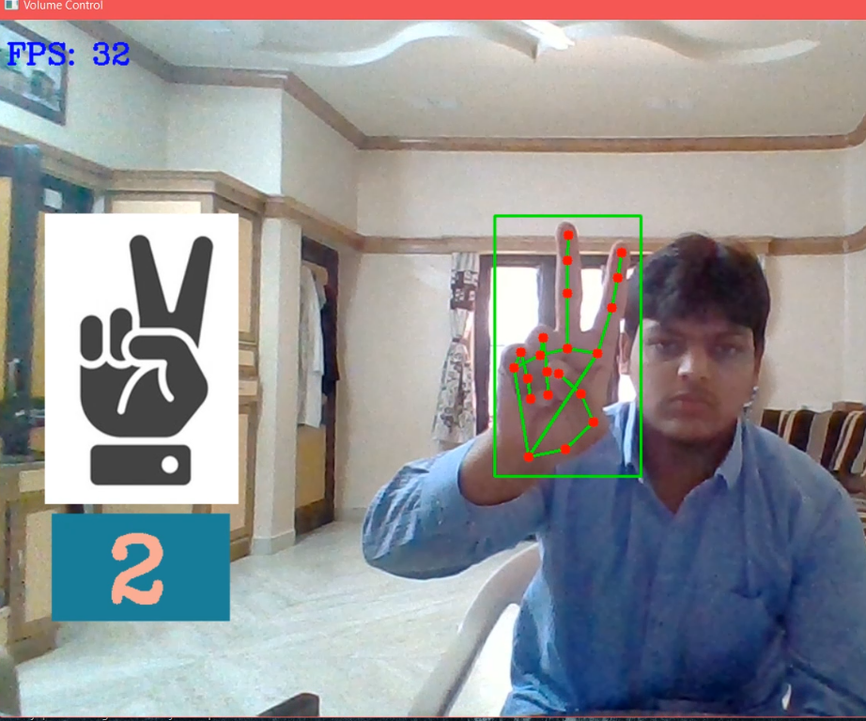

**Figure 4.1.4.2 Count 3**

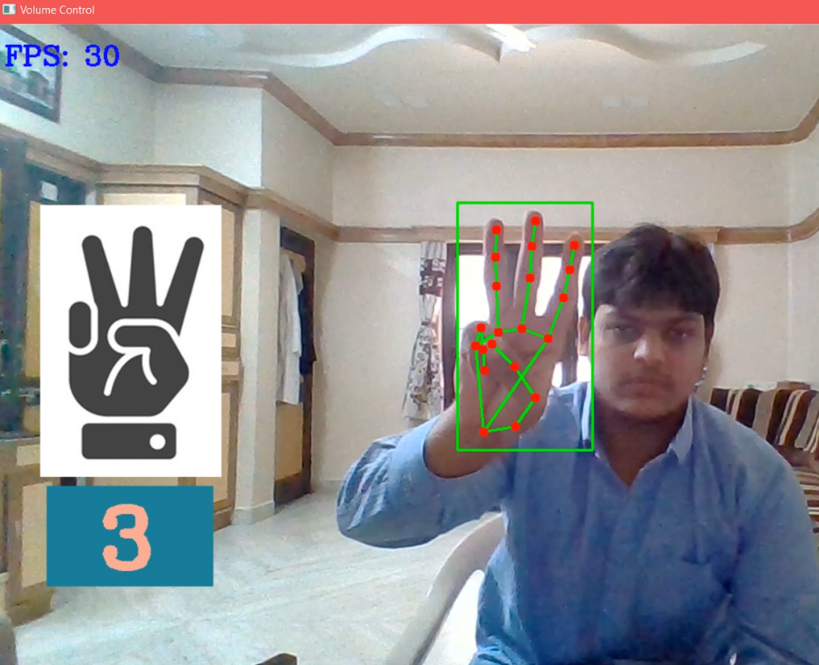

**Figure 4.1.4.3 Count 2**

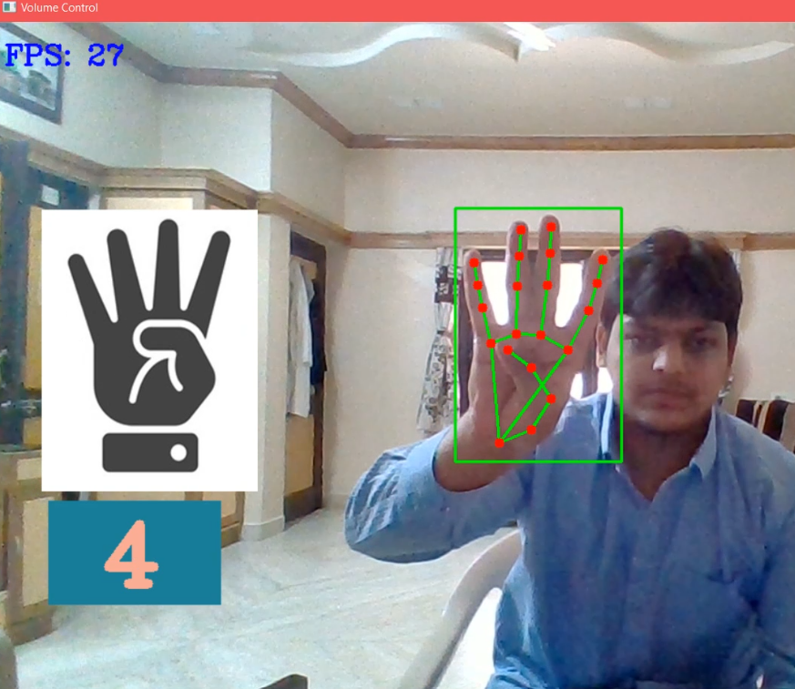

**Figure 4.1.4.4 Count 4**

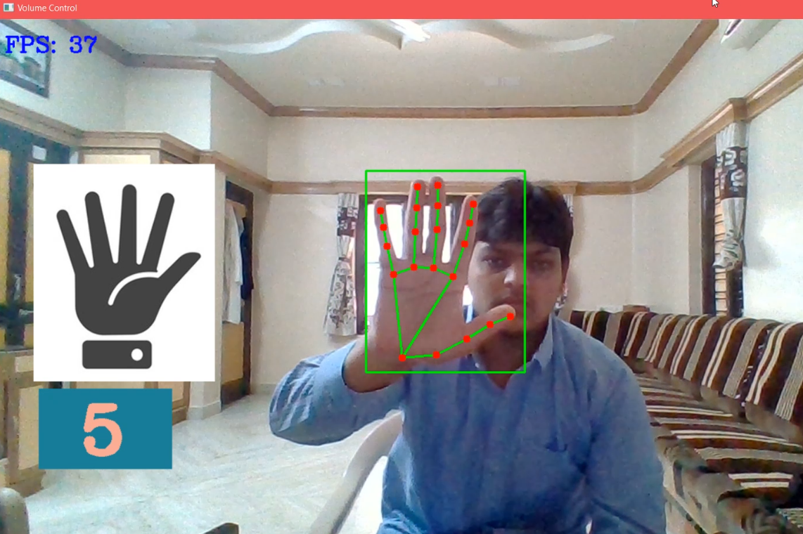

**Figure 4.1.4.5 Count 5**

**4.2. Virtual Mouse Application Module**

### 4.2.1. Introduction

With the development technologies in the areas of augmented reality and devices that we use in our daily life, these devices are becoming compact in the form of Bluetooth or wireless technologies. This paper proposes an AI virtual mouse system that makes use of the hand gestures and hand tip detection for performing mouse functions in the computer using computer vision. The main objective of the proposed system is to perform computer mouse cursor functions and scroll function using a web camera or a built-in camera in the computer instead of using a traditional mouse device. Hand gesture and hand tip detection by using computer vision is used as a HCI with the computer. With the use of the AI virtual mouse system, we can track the fingertip of the hand gesture by using a built-in camera or web camera and perform the mouse cursor operations and scrolling function and also move the cursor with it.

While using a wireless or a Bluetooth mouse, some devices such as the mouse, the dongle to connect to the PC, and also, a battery to power the mouse to operate are used, but in this paper, the user uses his/her built-in camera or a webcam and uses his/her hand gestures to control the computer mouse operations. In the proposed system, the web camera captures and then processes the frames that have been captured and then recognizes the various hand gestures and hand tip gestures and then performs the particular mouse function.

Python programming language is used for developing the AI virtual mouse system, and also, OpenCV which is the library for computer vision is used in the AI virtual mouse system. In the proposed AI virtual mouse system, the model makes use of the MediaPipe package for the tracking of the hands and for tracking of the tip of the hands, and also, Pynput, Autopy, and PyAutoGUI packages were used for moving around the window screen of the computer for performing functions such as left click, right click, and scrolling functions. The results of the proposed model showed very high accuracy level, and the proposed model can work very well in real-world application with the use of a CPU without the use of a GPU.

### 4.2.2. The Camera Used in the AI Virtual Mouse System

The proposed AI virtual mouse system is based on the frames that have been captured by the webcam in a laptop or PC. By using the Python computer vision library OpenCV, the video capture object is created and the web camera will start capturing video. The web camera captures and passes the frames to the AI virtual system.

### 4.2.3. Capturing the Video and Processing

The AI virtual mouse system uses the webcam where each frame is captured till the termination of the program. The video frames are processed from BGR to RGB colour space to find the hands in the video frame by frame as shown in the following code:

def findHands(self, img, draw = True):

imgRGB = cv2.cvtColor(img, cv2.COLOR\_BGR2RGB)

self.results = self.hands.process(imgRGB)

### 4.2.4. Rectangular Region for Moving through the Window

The AI virtual mouse system makes use of the transformational algorithm, and it converts the co-ordinates of fingertip from the webcam screen to the computer window full screen for controlling the mouse. When the hands are detected and when we find which finger is up for performing the specific mouse function, a rectangular box is drawn with respect to the computer window in the webcam region where we move throughout the window using the mouse cursor.

### 4.2.5. Detecting Which Finger Is Up and Performing the Particular Mouse Function

In this stage, we are detecting which finger is up using the tip Id of the respective finger that we found using the MediaPipe and the respective co-ordinates of the fingers that are up and according to that, the particular mouse function is performed.

### 4.2.6. For the Mouse to Perform Left Button Click

If both the index finger with tip Id = 1 and the middle finger with tip Id = 2 are up and the distance between the two fingers is lesser than 30px, the computer is made to perform the left mouse button click using the pynput Python package.

### 4.2.7. For No Action to be Performed on the Screen

If all the fingers are up with tip Id = 0, 1, 2, 3, and 4, the computer is made to not perform any mouse events in the screen.

### 4.2.8. Result Analysis & I/O Specification

* Virtual Mouse is an idea of implementing an adaptable, multi-functional navigation/interaction tool that overcomes physical barriers.
* The system is 'real' enough to not affect the interaction much.
* Ease of use is the foremost concern.

This application can control mouse tasks, such as:

* Clicking
* Scrolling.
* Additional Feature (Show/Hide Desktop).

Our system tracks just one hand to recognize its gestures.

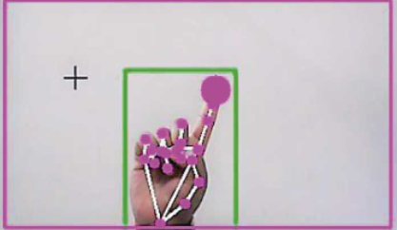

**Figure 4.2.8.1 Moving Cursor**

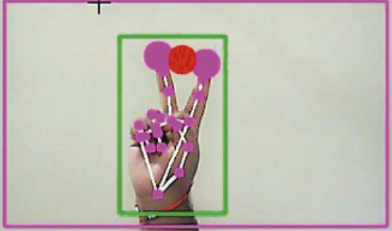

**Figure 4.2.8.2 Mouse Click**

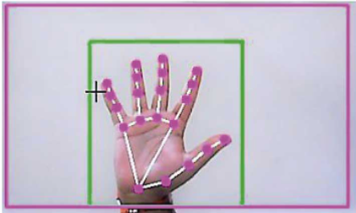

**Figure 4.2.8.3 No Mouse Operation**

**4.3. Volume Control Application Module**

### 4.3.1. Introduction

Gesture recognition helps computers to understand human body language. This helps to build a more potent link between humans and machines, rather than just the basic text user interfaces or graphical user interfaces (GUIs). In this project for gesture recognition, the human body’s motions are read by computer camera. The computer then makes use of this data as input to handle applications. The objective of this project is to develop an interface which will capture human hand gesture dynamically and will control the volume level.

NumPy is a library for the Python programming language, adding support for large, multi-dimensional arrays and matrices, along with a large collection of high-level mathematical functions to operate on these arrays.

Mediapipe is an open-source machine learning library of Google, which has some solutions for face recognition and gesture recognition, and provides encapsulation of python, js and other languages. MediaPipe Hands is a high-fidelity hand and finger tracking solution. It uses machine learning (ML) to infer 21 key 3D hand information from just one frame. We can use it to extract the coordinates of the key points of the hand.

### 4.3.2. Working Principal of Volume Control

The camera in our device is used for this project. It detects our hand with points in it so as it can see the distance between our thumb fingertip and index finger tip. The distance between the points 4 and 8 is directly proportional to the volume of device.

* Detect hand landmarks
* Calculate the distance between thumb tip and index finger tip.
* Map the distance of thumb tip and index finger tip with volume range. For my case, distance between thumb tip and index finger tip was within the range of 30 – 350 and the volume range was from -63.5 – 0.0.
* In order to exit press ‘Spacebar'

### 4.3.3. Result Analysis & I/O Specification

* In this application, we’ll track our hand with our specific fore, thumb and little fingers to control the volume application.
* The objective of this project is to develop an interface which will capture human hand gesture dynamically and will control the volume level.
* Ease of use is the foremost concern.

This application can control volume task, such as:

* Increase the volume.
* Decrease the volume.
* Mute the volume.

Our system tracks just one hand to recognize its gestures.

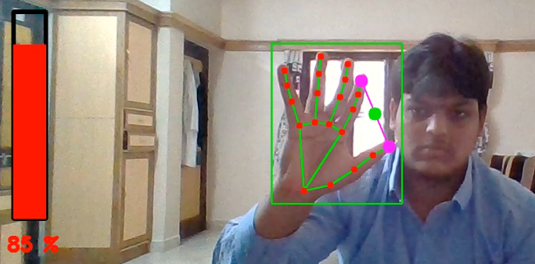

**Figure 4.3.3.1 Volume Increase**

### 

**Figure 4.3.3.2 Volume Decrease**

**4.4. Gender Detection Application Module**

### 4.4.1. Introduction

The problem of gender prediction and classification is closely related to face detection. One of the first method for gender classification was SEXNET introduced by Golomb et al. It classified images sampled at 30 x 30 pixels using a fully connected neural network with 3 layers of 900, 40 and 900 neurons. Another method introduced by Moghaddam and Yang uses Support Vector Machines to classify gender. The method used subsampled images of 21 x 21 pixels and classified them using SV M with radial basis function kernel. More recently the gender classification problem has been treated as a subproblem of age prediction. Current approaches use the same neural network architecture for age as well as gender prediction. Gender can be easily modelled as a binary classification problem. If the gender is modelled using regression, we can view the output number as confidence.

### 4.4.2. Gender Prediction

The final stage is gender estimation. For our application, we decided to train our own models. We discuss the training process and evaluation of trained models. Additionally, we chose to train a different set of models with 4 colour channels. Many popular face detection methods use integral images to find faces. We add the integral image as an additional colour channel. In our application we provide both standard models and models with 4 colour channels. After face detection the detected faces are first fed to the age estimation model and then to the gender estimation model. The results can be displayed on the original image. Otherwise, the result is returned by the prediction function.

### 4.4.3. Gender Network

We trained the gender estimation networks similarly to age estimation networks. The best learning rate for Adam optimizer is 0.001 achieving Table 4.4.3.1: Validation loss for each combination for training the gender network.

**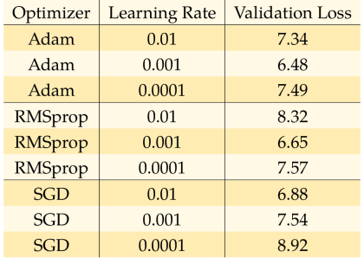**

(A)

**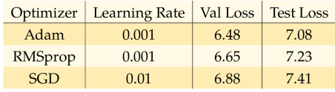**

(B)

**Table 4.4.3.1 Gender Network (A & B)**

validation loss of 0.09. For RMS prop optimizer the best result we achieved is validation loss of 0.09 for learning rate of 0.001. Finally, with gradient descent optimizer we achieved validation loss of 0.1 for learning rate 0.01. It is interesting to note that learning rate of 0.0001 was too low and the model achieved validation loss as high as 0.47. On Table 4.4.3.2 we can see comparison of validation loss after 60 epochs for each combination. The best optimizer and learning rate combination was RMSprop with learning rate equal to 0.001. However, Ada m optimizer with learning rates 0.001 and 0.0001 as well as RMSprop optimizer with learning rate 0.0001 and gradient descent optimizer with learning.

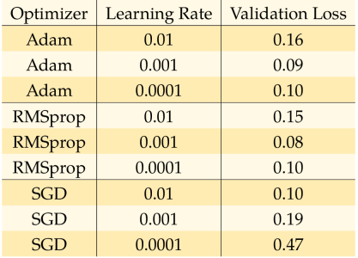

(A)

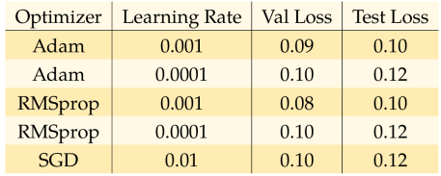

(B)

**Table 4.4.3.2 Gender Validation (A & B)**

The best performing combination of optimizer and learning rate based on the evaluation on validation and test datasets was RMSprop with learning rate 0.001. The results of all evaluated combinations are displayed in Table 4.4.3.2.

### 4.4.4. Model Training

Each dataset uses different style of labelling, some datasets contain mislabelled images or do not contain recognisable face. The SSR-Net method requires separate networks for gender predictions. Therefore, it was necessary to prepare the data for training. For training the age prediction we processed the datasets with images labelled with age labels. Each image was passed through MTCN N face detector. If a face was detected with confidence greater than 95% and labels were not missing, the image was added to filtered dataset. Each filtered dataset was then split to training, validation and test subsets with ratios 80%, 10% and 10% respectively. For gender prediction training, the process was similar. The filtered train, validation and test subsets were then combined to form a large dataset. Table 4.4.4.1 provides an overview of the sizes of subsets of the large training dataset. Table 4.4.4.2 shows the number of male and female subjects in combined dataset for gender training. We trained the model with different optimizer and different starting learning rate. For optimizers we use standard gradient descent, RMSprop and Ada m optimizer. For starting learning rate we used 1 x I0~k, k = 1...4. The main disadvantage of standard gradient descent is that it is not adaptive. The choice of proper learning rate is crucial and the same learning rate applies to all parameters. Another issue arises when the error function is highly non-convex and the model can get trapped in a local minimum or in a saddle point where the gradient is close to zero.



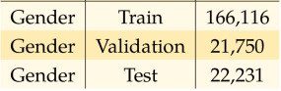

**Table 4.4.4.1 Gender Training**

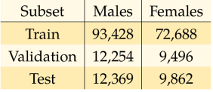

**Table 4.4.4.2 Validation Training**

RMSprop or Root Mean Square Propagation tries to address the issues of gradient descent by dividing the learning rate by an exponentially weighted average of squared gradient. Let's assume a mini-batch of size T. Equation 5.1 shows the update of weight wu at time t + 1. The author of RMSprop suggests for 7 value 0.9. The parameter 8 is a smoothing term to avoid division by zero.

### 4.4.5. Result Analysis & I/O Specification

* In this application, we will detect our face through the webcam.
* The objective of this project is to develop an interface which will automatically detect faces in a static image and to predict the gender of the spotted persons using a predefine deep learning-based gender detection model.
* Ease of use is the foremost concern.

This application performs face task, such as:

* Detecting the multiple faces at same time.
* Show the person gender status.

Our system tracks multiple human faces to recognize its gender.

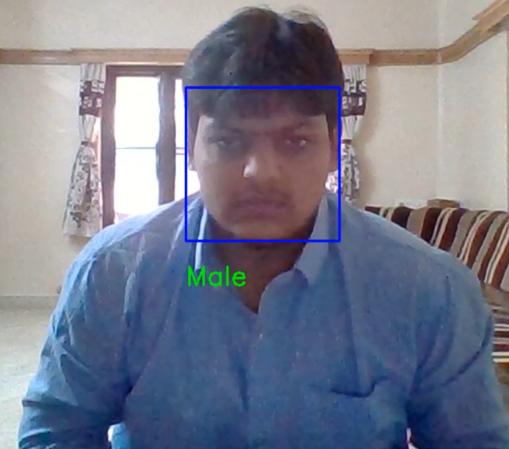

**Figure 4.4.5.1 Gender Detection**

**4.5. Emotions Detection Application Module**

### 4.5.1. Introduction

The literature review examined earlier showed that multiple solutions to the emotion detection problem were implemented using deep learning, the Fisher Face or the Eigenface algorithms. Choosing OpenCV as the computer vision library to be utilised for this project meant that I had access to both face detection and recognition algorithms. For face detection, deep learning or the Viola Jones algorithm can be used whilst for recognition, either the Fisher Face, Eigenface or LBP algorithms can be used. My goal at this point was to retrain the face recognition module to recognise emotions rather than any individuals face.

### 4.5.2. Working Principal of Emotions Detection

The literature review showed that the methodology followed by many of the authors when attempting to recognise emotions is the same. There are 6 essential steps that are taken:

1. Split video clip into individual frames for processing.
2. Individual Frame gets passed to face detector.
3. Face is detected and extracted by the face detector.
4. Extracted face is passed to emotion recognition module.
5. Emotion recognition module identifies current emotion of face passed to it.
6. Repeat from step 1.

It made sense for me to follow the same steps as the authors in the literature, as I was attempting to build a system that could carry out the same tasks as theirs.

### 4.5.3. Emotion Detection:

At this stage of development, it was clear that I would need to re-train a face recognition algorithm to recognise emotions instead of face, so before diving into this I had to do some background research on machine learning. In summary, machine learning is the science of teaching a computer to learn from data. There are many different machine learning algorithms, and different algorithms are fit for different tasks, but regardless of the algorithm, they all have common elements:

* **Data:** All machine learning algorithms rely on data, as this is used to train the system. In my case, the training data was pictures of faces expressing an emotion.
* **Model:** The model of a machine learning algorithm is a mathematical framework developed for learning. In my case, the model was either one of the three face recognition algorithms provided by OpenCV.
* **Training:** In the sense of machine learning, training is the task of modifying the model so that for a given input, an output can be mapped. For example, a face detection algorithm can be fed thousands of pictures of faces (training data) and be told that these pictures all contain faces. Then it can be fed thousands of pictures of anything but faces and be told that these pictures do not contain any faces. Once the training has finished, the model should be modified so that when a new picture is input to the system it should be able to tell on its own if this picture contains a face.

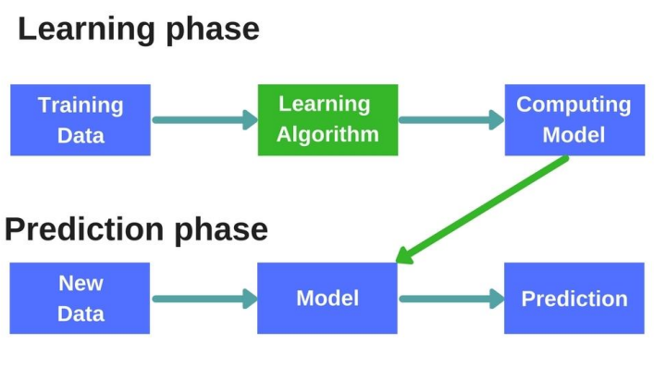

**Figure 4.5.3.1 Learning Phase**

For the emotion recognition module of the system as no model is included, a dataset was needed, the algorithm was provided and then the training needed to be carried out. The adopted approach was as follows. First data must be collected, this needed to be images of people’s faces expressing an emotion. The data needed to be sorted, so that subsets of data could be produced that contained an emotion. For example, a subset was “happy” and this contained pictures of people that were happy. Next the faces needed to be detected and extracted from the dataset and fed into the face recognition algorithm with its labels. So, all faces extracted from the “happy” subset were fed to the face recognition algorithm with the label of happy. Once training had finished, when a new happy face was fed into the system, it should have given an output indicating that “happy” was detected. In a sense I attempted to “trick” a face recognition algorithm, by telling it that every happy face corresponds to an individual labelled happy.

### 4.5.4. Emotion Detection Training:

Now that I had extracted the faces from the original datasets, I was left with four new datasets containing images of faces expressing emotions with the images sorted into their corresponding 30 directories. The next step in the process was to train the face recognition model to recognise emotions with the “newly” obtained datasets. The face recognition module of OpenCV comes with three pretrained face recognition algorithms. These are:

* **EigenFaces:** This is a technique that extracts the variance in facial features for each image in the training set. Then when the model is used, it tries to match the features extracted from the training set to the actual input data’s features.
* **FisherFaces:** Fisherfaces works in a similar way to EigeinFaces, but with the difference that with the FisherFaces technique, instead of extracting the variance in facial features, it extracts the features that differentiate one person from another.
* **LBPH:** This is a technique, where a 3x3 filter is passed over each pixel in an image that returns the binary equivalent value of the pixels within the filter. This binary value is dependent on the intensity value of each individual pixel. Then a Histogram is created that holds all the binary values for each face used in the training set. Then when a face is to be recognised, once it is passed through the LBP recognition model, the model attempts to match the current face’s LPBH with one from the training set.

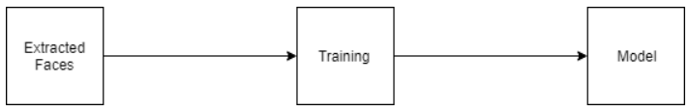

**Figure 4.5.4.1 Emotion Detection Training**

The approach to training the algorithms was as follows. First all the images for each emotion are shuffled and split into two separate sets, a test set and a training set. Then the training set is passed to the face recognition trainer with the corresponding label of each emotion in the set. Once the training has finished, the now trained model is used to try and predict the emotion in the prediction set. If the prediction is correct it is added to a variable that holds the correct prediction score, if it is incorrect then it is added to a variable that holds the incorrect prediction score. This is then used to calculate the accuracy of the algorithm. The process is repeated 10 times to make sure that the calculated prediction score is consistent.

### 4.5.5. Result Analysis & I/O Specification

* In this application, we will detect our face through the webcam.
* The objective of this project is to develop an interface which will automatically detect faces in a static image and to predict the gender of the spotted persons using a predefine deep learning-based gender detection model.
* Ease of use is the foremost concern.

This application performs face task, such as:

* Detecting the multiple faces at same time.
* Show the person emotions by their facial expression.

Our system tracks multiple human faces to recognize its emotions.

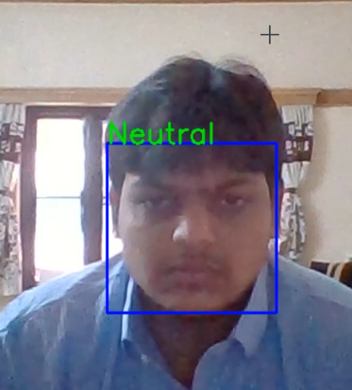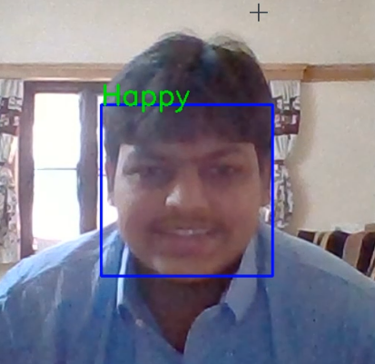 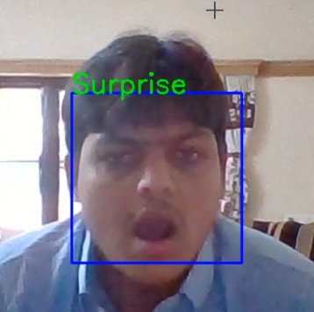

**Figure 4.5.5.1 Emotion Detection**

CHAPTER IV.II

**Hardware & Software Requirements**

**Chapter IV.II: Hardware & Software Requirements**

* 1. **Hardware Requirements**
* A simple webcam capable of acquiring RGB images.
* Minimum 1GB GPU GeForce Series.
* i3 processor or above version processors.
* Minimum 4 GB RAM.
  1. **Software Requirements**
* Windows 7 or above version operating system.
* Webcam Drivers.
* Python 3.5 or above version.
* Python Machine & Deep Learning Frameworks, Libraries & API.

CHAPTER IV.III

**Application Tools**

**Chapter IV.III: Application Tools**

### 6.1 Python

Python is a general-purpose interpreted, interactive, object-oriented, and high-level programming language. It was created by Guido van Rossum during 1985- 1990. Like Perl, Python source code is also available under the GNU General Public License (GPL). This tutorial gives enough understanding on Python programming language.

Python is a high-level, interpreted, interactive and object-oriented scripting language. Python is designed to be highly readable. It uses English keywords frequently where as other languages use punctuation, and it has fewer syntactical constructions than other languages.

Python is a MUST for students and working professionals to become a great Software Engineer specially when they are working in Web Development Domain. I will list down some of the key advantages of learning Python:

* **Python is Interpreted** − Python is processed at runtime by the interpreter. You do not need to compile your program before executing it. This is similar to PERL and PHP.
* **Python is Interactive** − You can actually sit at a Python prompt and interact with the interpreter directly to write your programs.
* **Python is Object-Oriented** − Python supports Object-Oriented style or technique of programming that encapsulates code within objects.
* **Python is a Beginner's Language** − Python is a great language for the beginner-level programmers and supports the development of a wide range of applications from simple text processing to WWW browsers to games.

### 6.2. Python GUI - Tkinter

Python offers multiple options for developing GUI (Graphical User Interface). Out of all the GUI methods, tkinter is the most commonly used method. It is a standard Python interface to the Tk GUI toolkit shipped with Python. Python with tkinter is the fastest and easiest way to create the GUI applications. Creating a GUI using tkinter is an easy task.  
To create a tkinter app:

* Importing the module – tkinter
* Create the main window (container)
* Add any number of widgets to the main window
* Apply the event Trigger on the widgets.

Tkinter supports a range of Tcl/Tk versions, built either with or without thread support. The official Python binary release bundles Tcl/Tk 8.6 threaded. See the source code for the tkinter module for more information about supported versions. Tkinter is not a thin wrapper, but adds a fair amount of its own logic to make the experience more pythonic. This documentation will concentrate on these additions and changes, and refer to the official Tcl/Tk documentation for details that are unchanged.

### 6.3. MediaPipe

MediaPipe Hands utilizes an ML pipeline consisting of multiple models working together: A palm detection model that operates on the full image and returns an oriented hand bounding box. A hand landmark model that operates on the cropped image region defined by the palm detector and returns high-fidelity 3D hand key points. This strategy is similar to that employed in our [MediaPipe Face Mesh](https://google.github.io/mediapipe/solutions/face_mesh.html) solution, which uses a face detector together with a face landmark model.

Providing the accurately cropped hand image to the hand landmark model drastically reduces the need for data augmentation (e.g. rotations, translation and scale) and instead allows the network to dedicate most of its capacity towards coordinate prediction accuracy. In addition, in our pipeline the crops can also be generated based on the hand landmarks identified in the previous frame, and only when the landmark model could no longer identify hand presence is palm detection invoked to relocalize the hand.

The pipeline is implemented as a MediaPipe [graph](https://github.com/google/mediapipe/tree/master/mediapipe/graphs/hand_tracking/hand_tracking_mobile.pbtxt) that uses a [hand landmark tracking subgraph](https://github.com/google/mediapipe/tree/master/mediapipe/modules/hand_landmark/hand_landmark_tracking_gpu.pbtxt) from the [hand landmark module](https://github.com/google/mediapipe/tree/master/mediapipe/modules/hand_landmark), and renders using a dedicated [hand renderer subgraph](https://github.com/google/mediapipe/tree/master/mediapipe/graphs/hand_tracking/subgraphs/hand_renderer_gpu.pbtxt). The [hand landmark tracking subgraph](https://github.com/google/mediapipe/tree/master/mediapipe/modules/hand_landmark/hand_landmark_tracking_gpu.pbtxt) internally uses a [hand landmark subgraph](https://github.com/google/mediapipe/tree/master/mediapipe/modules/hand_landmark/hand_landmark_gpu.pbtxt) from the same module and a [palm detection subgraph](https://github.com/google/mediapipe/tree/master/mediapipe/modules/palm_detection/palm_detection_gpu.pbtxt) from the [palm detection module](https://github.com/google/mediapipe/tree/master/mediapipe/modules/palm_detection).

### 6.3.1. Hand Configuration

#### **STATIC\_IMAGE\_MODE**

If set to false, the solution treats the input images as a video stream. It will try to detect hands in the first input images, and upon a successful detection further localizes the hand landmarks. In subsequent images, once all **[max\_num\_hands](https://google.github.io/mediapipe/solutions/hands" \l "max_num_hands)** hands are detected and the corresponding hand landmarks are localized, it simply tracks those landmarks without invoking another detection until it loses track of any of the hands. This reduces latency and is ideal for processing video frames. If set to true, hand detection runs on every input image, ideal for processing a batch of static, possibly unrelated, images. Default to false.

#### **MAX\_NUM\_HANDS**

Maximum number of hands to detect. Default to 2.

#### **MODEL\_COMPLEXITY**

Complexity of the hand landmark model: 0 or 1. Landmark accuracy as well as inference latency generally go up with the model complexity. Default to 1.

#### **MIN\_DETECTION\_CONFIDENCE**

Minimum confidence value ([0.0, 1.0]) from the hand detection model for the detection to be considered successful. Default to 0.5.

#### **MIN\_TRACKING\_CONFIDENCE:**

Minimum confidence value ([0.0, 1.0]) from the landmark-tracking model for the hand landmarks to be considered tracked successfully, or otherwise hand detection will be invoked automatically on the next input image. Setting it to a higher value can increase robustness of the solution, at the expense of a higher latency. Ignored if **[static\_image\_mode](https://google.github.io/mediapipe/solutions/hands" \l "static_image_mode)** is true, where hand detection simply runs on every image. Default to 0.5.

#### **Output**

Naming style may differ slightly across platforms/languages.

#### **MULTI\_HAND\_LANDMARKS**

Collection of detected/tracked hands, where each hand is represented as a list of 21 hand landmarks and each landmark is composed of x, y and z. x and y are normalized to [0.0, 1.0] by the image width and height respectively. z represents the landmark depth with the depth at the wrist being the origin, and the smaller the value the closer the landmark is to the camera. The magnitude of z uses roughly the same scale as x.

#### **MULTI\_HAND\_WORLD\_LANDMARKS**

Collection of detected/tracked hands, where each hand is represented as a list of 21 hand landmarks in world coordinates. Each landmark is composed of x, y and z: real-world 3D coordinates in meters with the origin at the hand’s approximate geometric centre.

#### **MULTI\_HANDEDNESS**

Collection of handedness of the detected/tracked hands (i.e., is it a left or right hand). Each hand is composed of label and score. label is a string of value either "Left" or "Right". score is the estimated probability of the predicted handedness and is always greater than or equal to 0.5 (and the opposite handedness has an estimated probability of 1 - score).

### 6.3.2. Face Configuration

#### **MODEL\_SELECTION**

An integer index 0 or 1. Use 0 to select a short-range model that works best for faces within 2 meters from the camera, and 1 for a full-range model best for faces within 5 meters. For the full-range option, a sparse model is used for its improved inference speed. Please refer to the [model cards](https://google.github.io/mediapipe/solutions/models.html#face_detection) for details. Default to 0 if not specified.

#### **MIN\_DETECTION\_CONFIDENCE**

Minimum confidence value ([0.0, 1.0]) from the face detection model for the detection to be considered successful. Default to 0.5.

#### **Output**

Naming style may differ slightly across platforms/languages.

#### **DETECTIONS**

Collection of detected faces, where each face is represented as a detection proto message that contains a bounding box and 6 key points (right eye, left eye, nose tip, mouth centre, right ear tragion, and left ear tragion). The bounding box is composed of xmin and width (both normalized to [0.0, 1.0] by the image width) and ymin and height (both normalized to [0.0, 1.0] by the image height). Each key point is composed of x and y, which are normalized to [0.0, 1.0] by the image width and height respectively.

### 6.4. OpenCV

OpenCV-Python is a library of Python bindings designed to solve computer vision problems. Python is a general-purpose programming language started by Guido van Rossum that became very popular very quickly, mainly because of its simplicity and code readability.

Python is a general-purpose programming language started by Guido van Rossum that became very popular very quickly, mainly because of its simplicity and code readability. It enables the programmer to express ideas in fewer lines of code without reducing readability.

Compared to languages like C/C++, Python is slower. That said, Python can be easily extended with C/C++, which allows us to write computationally intensive code in C/C++ and create Python wrappers that can be used as Python modules. This gives us two advantages: first, the code is as fast as the original C/C++ code (since it is the actual C++ code working in background) and second, it easier to code in Python than C/C++. OpenCV-Python is a Python wrapper for the original OpenCV C++ implementation.

OpenCV-Python makes use of NumPy, which is a highly optimized library for numerical operations with a MATLAB-style syntax. All the OpenCV array structures are converted to and from NumPy arrays. This also makes it easier to integrate with other libraries that use NumPy such as SciPy and Matplotlib.

### 6.5. NumPy

NumPy, which stands for Numerical Python, is a library consisting of multidimensional array objects and a collection of routines for processing those arrays. Using NumPy, mathematical and logical operations on arrays can be performed. This tutorial explains the basics of NumPy such as its architecture and environment. It also discusses the various array functions, types of indexing, etc. An introduction to Matplotlib is also provided. All this is explained with the help of examples for better understanding.

## **Operations using NumPy**

Using NumPy, a developer can perform the following operations −

* Mathematical and logical operations on arrays.
* Fourier transforms and routines for shape manipulation.
* Operations related to linear algebra. NumPy has in-built functions for linear algebra and random number generation.

### 6.6. AutoPy

AutoPy is a simple, cross-platform GUI automation library for Python. It includes functions for controlling the keyboard and mouse, finding colours and bitmaps on-screen, and displaying alerts. Currently supported on macOS, Windows, and X11 with the XTest extension.

### 6.7. TensorFlow Lite

TensorFlow Lite is a set of tools that enables on-device machine learning by helping developers run their models on mobile, embedded, and edge devices.

### Key features

* Optimized for on-device machine learning, by addressing 5 key constraints: latency (there's no round-trip to a server), privacy (no personal data leaves the device), connectivity (internet connectivity is not required), size (reduced model and binary size) and power consumption (efficient inference and a lack of network connections).
* Multiple platform support, covering [Android](https://www.tensorflow.org/lite/guide/android) and [iOS](https://www.tensorflow.org/lite/guide/ios) devices, [embedded Linux](https://www.tensorflow.org/lite/guide/python), and [microcontrollers](https://www.tensorflow.org/lite/microcontrollers).
* Diverse language support, which includes Java, Swift, Objective-C, C++, and Python.
* High performance, with [hardware acceleration](https://www.tensorflow.org/lite/performance/delegates) and [model optimization](https://www.tensorflow.org/lite/performance/model_optimization).
* End-to-end [examples](https://www.tensorflow.org/lite/examples), for common machine learning tasks such as image classification, object detection, pose estimation, question answering, text classification, etc. on multiple platforms.

### Generate a TensorFlow Lite Model

A TensorFlow Lite model is represented in a special efficient portable format known as [FlatBuffers](https://google.github.io/flatbuffers/) (identified by the tflite file extension). This provides several advantages over TensorFlow's protocol buffer model format such as reduced size (small code footprint) and faster inference (data is directly accessed without an extra parsing/unpacking step) that enables TensorFlow Lite to execute efficiently on devices with limited compute and memory resources.

A TensorFlow Lite model can optionally include metadata that has human-readable model description and machine-readable data for automatic generation of pre- and post-processing pipelines during on-device inference. Refer to [Add metadata](https://www.tensorflow.org/lite/convert/metadata) for more details.

You can generate a TensorFlow Lite model in the following ways:

* **Use an existing TensorFlow Lite model**: Refer to [TensorFlow Lite Examples](https://www.tensorflow.org/lite/examples) to pick an existing model. Models may or may not contain metadata.
* **Create a TensorFlow Lite model**: Use the [TensorFlow Lite Model Maker](https://www.tensorflow.org/lite/guide/model_maker) to create a model with your own custom dataset. By default, all models contain metadata.
* **Convert a TensorFlow model into a TensorFlow Lite model**: Use the [TensorFlow Lite Converter](https://www.tensorflow.org/lite/convert/index) to convert a TensorFlow model into a TensorFlow Lite model. During conversion, you can apply [optimizations](https://www.tensorflow.org/lite/performance/model_optimization) such as [quantization](https://www.tensorflow.org/lite/performance/post_training_quantization) to reduce model size and latency with minimal or no loss in accuracy. By default, all models don't contain metadata.

### Run Interface

Inference refers to the process of executing a TensorFlow Lite model on-device to make predictions based on input data. You can run inference in the following ways based on the model type:

* **Models without metadata**: Use the [TensorFlow Lite Interpreter](https://www.tensorflow.org/lite/guide/inference) API. Supported on multiple platforms and languages such as Java, Swift, C++, Objective-C and Python.
* **Models with metadata**: You can either leverage the out-of-box APIs using the [TensorFlow Lite Task Library](https://www.tensorflow.org/lite/inference_with_metadata/task_library/overview) or build custom inference pipelines with the [TensorFlow Lite Support Library](https://www.tensorflow.org/lite/inference_with_metadata/lite_support). On android devices, users can automatically generate code wrappers using the [Android Studio ML Model Binding](https://www.tensorflow.org/lite/inference_with_metadata/codegen#mlbinding) or the [TensorFlow Lite Code Generator](https://www.tensorflow.org/lite/inference_with_metadata/codegen#codegen). Supported only on Java (Android) while Swift (iOS) and C++ is work in progress.

On Android and iOS devices, you can improve performance using hardware acceleration. On either platforms you can use a [GPU Delegate](https://www.tensorflow.org/lite/performance/gpu), on android you can either use the [NNAPI Delegate](https://www.tensorflow.org/lite/performance/nnapi) (for newer devices) or the [Hexagon Delegate](https://www.tensorflow.org/lite/performance/hexagon_delegate) (on older devices) and on iOS you can use the [Core ML Delegate](https://www.tensorflow.org/lite/performance/coreml_delegate). To add support for new hardware accelerators, you can [define your own delegate](https://www.tensorflow.org/lite/performance/implementing_delegate).

### 6.8. PyCaw

Python Core Audio Windows Library, working for both Python2 and Python3.

### 6.9. Keras

Keras is an API designed for human beings, not machines. Keras follows best practices for reducing cognitive load: it offers consistent & simple APIs, it minimizes the number of user actions required for common use cases, and it provides clear & actionable error messages. It also has extensive documentation and developer guides.

#### **Iterate At the Speed of Thought:**

Keras is the most used deep learning framework among top-5 winning teams on [Kaggle](https://www.kaggle.com/). Because Keras makes it easier to run new experiments, it empowers you to try more ideas than your competition, faster. And this is how you win.

#### **Exascale machine learning:**

Built on top of [TensorFlow 2](https://www.tensorflow.org/), Keras is an industry-strength framework that can scale to large clusters of GPUs or an entire [TPU pod](https://cloud.google.com/tpu). It's not only possible; it's easy.

#### **Deploy anywhere:**

Take advantage of the full deployment capabilities of the TensorFlow platform. You can export Keras models to JavaScript to run directly in the browser, to TF Lite to run on iOS, Android, and embedded devices. It's also easy to serve Keras models as via a web API.

#### **A vast ecosystem:**

Keras is a central part of the tightly-connected TensorFlow 2 ecosystem, covering every step of the machine learning workflow, from data management to hyperparameter training to deployment solutions.

#### **State-of-the-art research:**

Keras is used by CERN, NASA, NIH, and many more scientific organizations around the world (and yes, Keras is used at the LHC). Keras has the low-level flexibility to implement arbitrary research ideas while offering optional high-level convenience features to speed up experimentation cycles.

#### **An accessible superpower:**

Because of its ease-of-use and focus on user experience, Keras is the deep learning solution of choice for many university courses. It is widely recommended as one of the best ways to learn deep learning.

### 6.10. Haarcascades Model

Haar cascades, first introduced by Viola and Jones in their seminal 2001 publication, [Rapid Object Detection using a Boosted Cascade of Simple Features](https://www.cs.cmu.edu/~efros/courses/LBMV07/Papers/viola-cvpr-01.pdf), are arguably OpenCV’s most popular object detection algorithm.

Sure, many algorithms are more accurate than Haar cascades (HOG + Linear SVM, SSDs, Faster R-CNN, YOLO, to name a few), but they are still relevant and useful today.

One of the primary benefits of Haar cascades is that they are just so fast — it’s hard to beat their speed.

The downside to Haar cascades is that they tend to be prone to false-positive detections, require parameter tuning when being applied for inference/detection, and just, in general, are not as accurate as the more “modern” algorithms we have today.

That said, Haar cascades are:

* An important part of the computer vision and image processing literature
* Still used with OpenCV
* Still useful, particularly when working in resource-constrained devices when we cannot afford to use more computationally expensive object detectors

In the remainder of this tutorial, you’ll learn about Haar cascades, including how to use them with OpenCV.

CHAPTER IV.IV

**Algorithm Used**

**Chapter IV.IV: Algorithm Used**

**7. Face Recognition Algorithm**

### 7.1. [****Local Binary Patterns Histograms (LBPH)****](https://en.wikipedia.org/wiki/Local_binary_patterns)

### 7.1.1 Introduction

It was first described in 1994 (LBP) and has since been found to be a powerful feature for texture classification. It has further been determined that when LBP is combined with histograms of oriented gradients (HOG) descriptor, it improves the detection performance considerably on some datasets.

Using the LBP combined with histograms we can represent the face images with a simple data vector.

As LBP is a visual descriptor it can also be used for face recognition tasks, as can be seen in the following step-by-step explanation.

### Proposed Algorithm

Now that we know a little more about face recognition and the LBPH, let’s go further and see the steps of the algorithm:

1. **Parameters:** the **LBPH** uses 4 parameters:

* **Radius:** the radius is used to build the circular local binary pattern and represents the radius around the central pixel. It is usually set to 1.
* **Neighbors:** the number of sample points to build the circular local binary pattern. Keep in mind: the more sample points you include, the higher the computational cost. It is usually set to 8.
* **Grid X:** the number of cells in the horizontal direction. The more cells, the finer the grid, the higher the dimensionality of the resulting feature vector. It is usually set to 8.
* **Grid Y:** the number of cells in the vertical direction. The more cells, the finer the grid, the higher the dimensionality of the resulting feature vector. It is usually set to 8.

Don’t worry about the parameters right now, you will understand them after reading the next steps.

1. **Training the Algorithm**:

First, we need to train the algorithm. To do so, we need to use a dataset with the facial images of the people we want to recognize. We need to also set an ID (it may be a number or the name of the person) for each image, so the algorithm will use this information to recognize an input image and give you an output. Images of the same person must have the same ID. With the training set already constructed, let’s see the LBPH computational steps.

1. **Applying the LBP operation**:

The first computational step of the LBPH is to create an intermediate image that describes the original image in a better way, by highlighting the facial characteristics. To do so, the algorithm uses a concept of a sliding window, based on the parameter’s **radius** and **neighbors**.

The image below shows this procedure:

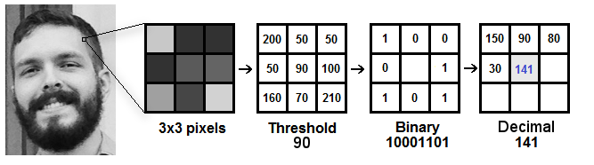

**Figure 7.1.2.1 LBP Operation**

Based on the image above, let’s break it into several small steps so we can understand it easily:

* Suppose we have a facial image in grayscale.
* We can get part of this image as a window of 3x3 pixels.
* It can also be represented as a 3x3 matrix containing the intensity of each pixel (0~255).
* Then, we need to take the central value of the matrix to be used as the threshold.
* This value will be used to define the new values from the 8 neighbors.
* For each neighbor of the central value (threshold), we set a new binary value. We set 1 for values equal or higher than the threshold and 0 for values lower than the threshold.
* Now, the matrix will contain only binary values (ignoring the central value). We need to concatenate each binary value from each position from the matrix line by line into a new binary value (e.g. 10001101). Note: some authors use other approaches to concatenate the binary values (e.g. clockwise direction), but the final result will be the same.
* Then, we convert this binary value to a decimal value and set it to the central value of the matrix, which is actually a pixel from the original image.
* At the end of this procedure (LBP procedure), we have a new image which represents better the characteristics of the original image.

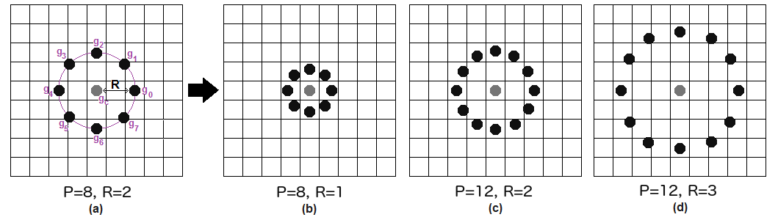

**Figure 7.1.2.2 LBP Procedure**

It can be done by using **bilinear interpolation**. If some data point is between the pixels, it uses the values from the 4 nearest pixels (2x2) to estimate the value of the new data point.

1. **Extracting the Histograms**:

Now, using the image generated in the last step, we can use the **Grid X** and **Grid Y** parameters to divide the image into multiple grids, as can be seen in the following image:

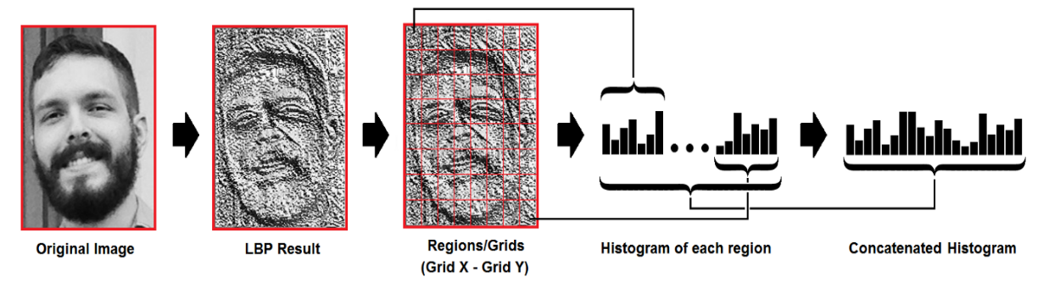

**Figure 7.1.2.3 Extracting the Histograms**

Based on the image above, we can extract the histogram of each region as follows:

* As we have an image in grayscale, each histogram (from each grid) will contain only 256 positions (0~255) representing the occurrences of each pixel intensity.
* Then, we need to concatenate each histogram to create a new and bigger histogram. Supposing we have 8x8 grids, we will have 8x8x256=16.384 positions in the final histogram. The final histogram represents the characteristics of the image original image.

The LBPH algorithm is pretty much it.

1. **Performing the face recognition:**

In this step, the algorithm is already trained. Each histogram created is used to represent each image from the training dataset. So, given an input image, we perform the steps again for this new image and creates a histogram which represents the image.

* So, to find the image that matches the input image we just need to compare two histograms and return the image with the closest histogram.
* We can use various approaches to compare the histograms (calculate the distance between two histograms), for example: Euclidean distance, chi-square, absolute value, etc. In this example, we can use the Euclidean distance (which is quite known) based on the following formula:

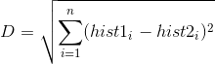

* So, the algorithm output is the ID from the image with the closest histogram. The algorithm should also return the calculated distance, which can be used as a ‘confidence’ measurement. Note: don’t be fooled about the ‘confidence’ name, as lower confidences are better because it means the distance between the two histograms is closer.
* We can then use a threshold and the ‘confidence’ to automatically estimate if the algorithm has correctly recognized the image. We can assume that the algorithm has successfully recognized if the confidence is lower than the threshold defined.

**8. Hand Gesture Algorithm**

### 8.1. [SVM](https://en.wikipedia.org/wiki/Local_binary_patterns) & HOG

### 8.1.1. Introduction

The problem of visual hand recognition and tracking is quite challenging. Many approaches used position markers or coloured bands to make the problem of hand recognition easier. However, they cannot be considered as a natural interface for the robot control due to their inconvenience. The motion recognition problem can be solved by combining basic image processing problems, namely, object detection, recognition, and tracking. There are many image processing algorithms that have been developed in target detection and recognition. They are divided into two main groups, namely, advanced machine learning (ML) and deep learning (DL) techniques.

ML techniques are general terms commonly used with basic feature extraction methods from original data and then combining, for example, SVM, decision tree, and nearest-neighbor, to train identity models. There are several extraction techniques for typical object detection as follows:

* Viola–Jones target detection technique: it is the first technique in real-time target detection based on Haar feature extraction. This technique is commonly used in face detection.
* Scale-invariant feature transform (SIFT): the special feature of SIFT is scale-invariant since it gives stable results with different aspect ratios of the image. Besides, the algorithm is rotation-invariant that ensures the result with different rotations of the object.
* HOG: it is calculated on a dense grid of cells and normalized the contrast between blocks to improve accuracy. It is mainly used to describe the shape and appearance of an object of the image.

### 8.1.2. Proposed Algorithm

The goal of the algorithm is to detect gestures with real-time processing speed, minimize interference, and reduce the ability to capture unintentional gestures. Their datasets are depicted in Figure [8.1.2.1](https://www.hindawi.com/journals/jr/2021/3986497/fig1/).

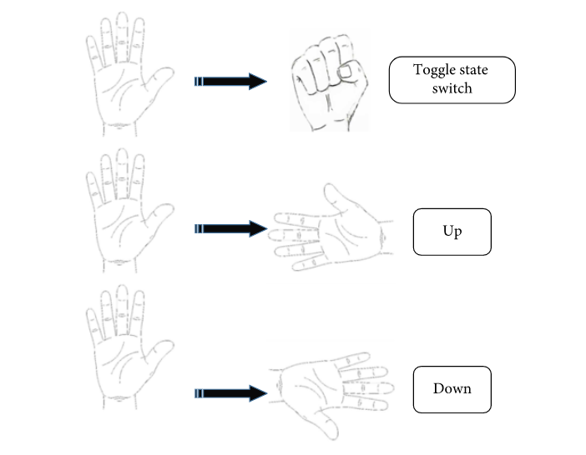

**Figure 8.1.2.1 Hand Gesture Proposed**

The proposed algorithm will perform as shown in Figure [8.1.2.](https://www.hindawi.com/journals/jr/2021/3986497/fig1/)2. In the model, the image is processed in real time. We will then conduct hand-holding area detection based on the previous model. The system then extracts the region of interest (ROI) of the frame. The object tracking module will get the coordinates of ROI and lock the track object for the next frames. Next, the identity module is activated to evaluate ROI whether the gesture has started or not. As a result, it will decide to continue to perform ROI of the next frames to find the ending and drawing gesture.

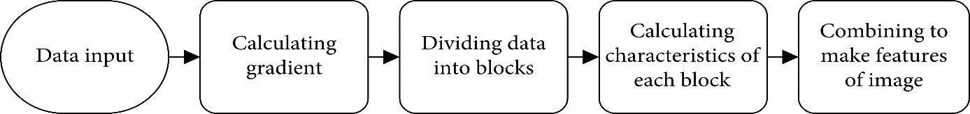

### 

**Figure 8.1.2.2 ROI Model**

### 8.1.3. Overview of Techniques

### 8.1.3.1. Detecting Object

The technique has two requirements. The first requirement is to detect the image that contains the object or not. The second requirement is to find out the position of the subject of the image. As introduced in the previous section, there are many algorithms that perform the task. In this study, the requirement is the accuracy of the results as well as being fast enough to operate for real-time applications. In the system, the action is the object detection operation. Therefore, it is necessary to select techniques with relatively fast calculation speed. Therefore, our implementation idea is to use the multiscale and sliding window technique to separate the image into ROI. We then crop the image from those ROI regions and extract their HOG feature. The SVM technique is used to classify whether an image contains an object or not. We then conclude that areas are likely to contain objects. Finally, we use the nonmaximum suppression technique to find the most suitable ROI.

### 8.1.3.2. Tracking Object

When the algorithm has detected the frame containing the object as well as the ROI area, the next thing is to lock and track the target when it is moving or may be partially deformed in the next frames.

The use of the tracking object will be necessary since the user of gesture will take place in a few seconds. If we continue to use classification and detection techniques to conclude, it will be difficult to achieve the desired processing speed or it may lead to false conclusions. For example, the action initiates ending the gesture that comes from two completely different objects.

During the intermediate stage between starting and ending of gesture, the subject may be partially deformed. It is difficult to use detection techniques. The requirement for object tracking technique in this problem is fast adhesion with acceptable accuracy. In this study, we select kernelized correlation filter (KCF) algorithm to track the object. The algorithm has good speed and consistent accuracy. It will not restore tracking target when losing its target that will reduce noise for the gesture control system.

### 8.1.3.3. Object Classification Technique

Object classification techniques are particularly applied for image processing. In artificial intelligence applications, the classifier requirements are to be able to distinguish the gestures that begin with each other. The required accuracy is high and this will ensure the desired level of control accuracy. Processing speed is not required too high since information containing object is known and categorization does not occur continuously in every frame.

When the object (gesture is detected) contains the target, the next task is to recognize them. Once gesture recognition begins, we continue to track the target and end gesture. To perform the task, we choose the convolutional neural network (CNN) model. CNN is used in many problems such as image recognition, video analysis, MRI images, and natural language processing.

### 8.1.4. Real-Time Object Tracking Technique

Due to real-time applications, modern object trackers try to reconcile as many samples as possible and keep the computation low. Kernelized correlation filter (KCF) is a variant of correlation filter. In the filter, the correlation between two samples is taken. When these samples match, the correlation value is the highest. A correlation can be found between the version of root (ROI area contains the tracked target) and ROI region at the same location in the next frame. This indicates the direction the tracked subject has moved in.

In the standard correlation filter, the following object model is not updated. If the object image changes significantly, the tracker performance decreases. In the KCF tracker, the model of the object being monitored is updated directly and continuously using the linear ridge regression model.

The process of adhering to targets using the basic KCF method consists of the following steps:

* Determination of grip area: it can be the initial user-defined area or an area detected by the system from the previous frame.
* Description of features: define the characteristics of the image area.
* Regression training: the detected ROI features will be added to form a dataset including past and present features as a basis for rapid training.
* The results after regression training are a new model, and the model is the basis for the next target detection step

The characteristics of the KCF method are relatively high accuracy, medium speed, and especially inability to recover when losing targets in a short time. Therefore, we choose the method for the paper.

CHAPTER IV.V

**Snapshots**

**Chapter IV.V: Screenshots**

**9.1. Application GUI Snapshot**

**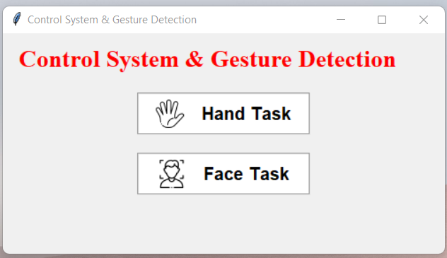**

**Snapshot 9.1.1 CSGD Application**

**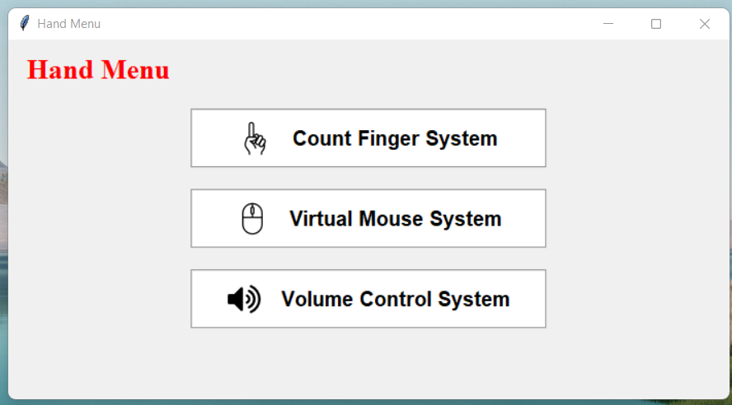**

**Snapshot 9.1.2 CSGD Application**

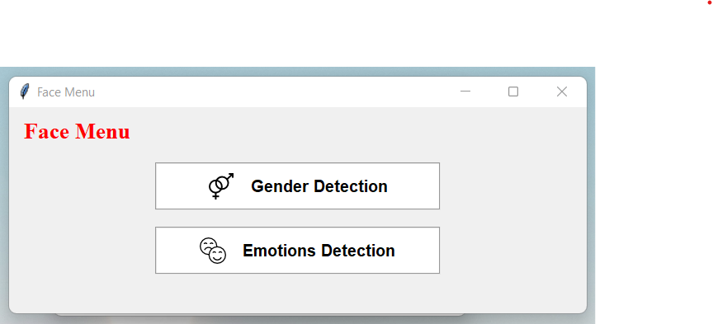

**Snapshot 9.1.3 CSGD Application**

**9.2. Finger Counting Application**

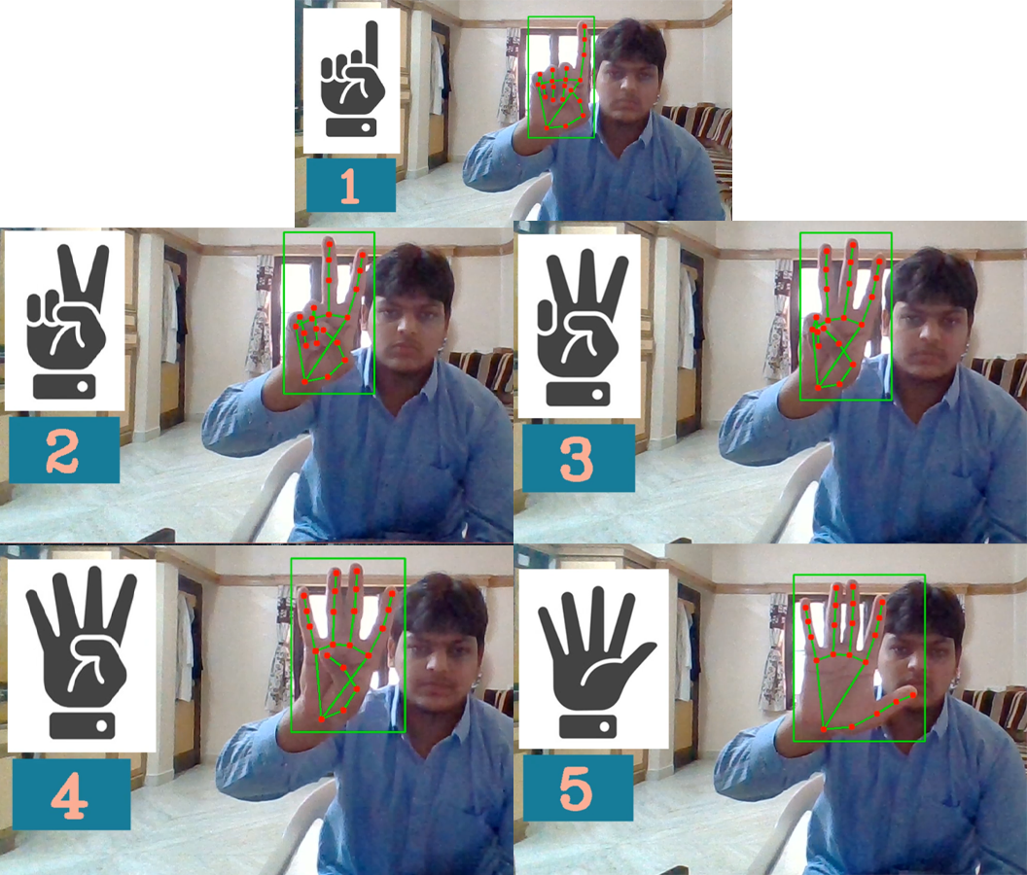

**Snapshot 9.2.1 Finger Counting Application**

**9.3. Virtual Mouse Application**

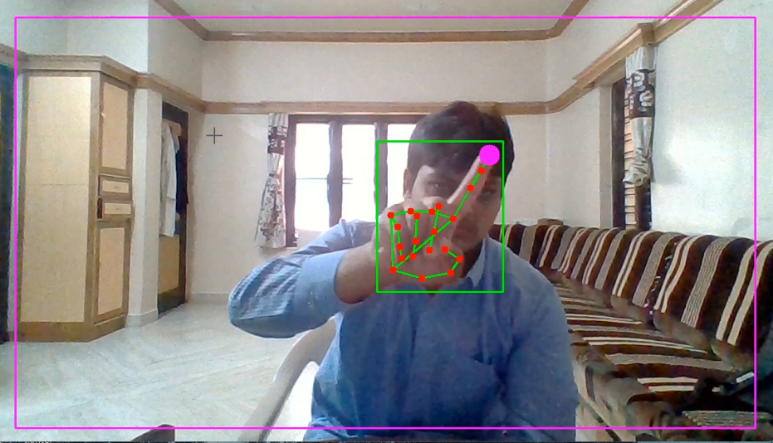

**Snapshot 9.3.1 Mouse Control**

**9.4. Volume Control Application**

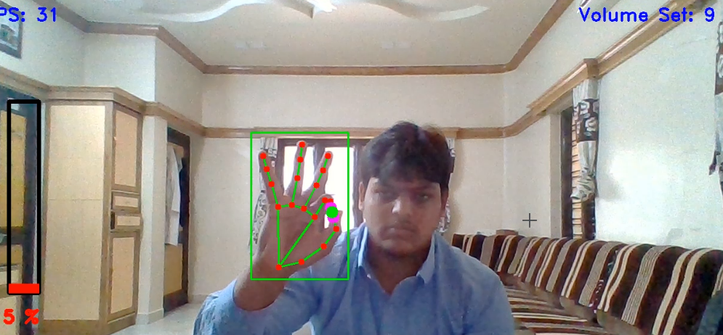

**Snapshot 9.4.1 Volume Control System**



**Snapshot 9.4.2 Volume Control System**

**9.5. Gender Detection Application**



**Snapshot 9.5.1 Gender Detection**

**9.6. Emotions Detection Application**

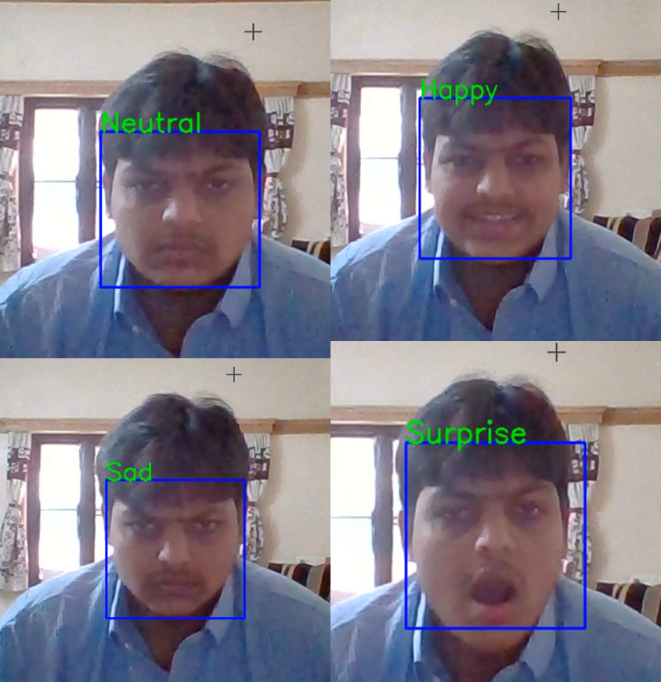

**Snapshot 9.6.1 Emotions Detection**

CHAPTER V

**Advantages & Disadvantages**

**Chapter V: Advantages & Disadvantages**

* 1. **Advantages for Hand Gesturing**
* Easy to use
* Hassle free
* Fun to use
* More interactive
  1. **Disadvantages for Hand Gesturing**
* Can’t be used for long distance
* Sometimes not accurate
* Requires a decent camera
* May be confused by two palms
  1. **Advantages for Face Detection**
* Better security
* Easy integration
* Automated identification
  1. **Disadvantages for Face Detection**
* Huge storage requirements
* Vulnerable detection
* Potential privacy issues

CHAPTER VI

**Conclusion**

**Chapter VI: Conclusion**

Different applications of hand gesture and facial recognition have been implemented in different domains.

Hand gesture and facial recognition is an emerging technology that can provide many benefits. It can save resources and time, and even generate new income streams, for companies that implement it right.

If any company that implemented the technology today might gain a competitive advantage in the future.

CHAPTER VII

**Future Scope**

**Chapter VII: Future Scope**

Various hand gestures can be recognized and applied as input to the computer. The hand gestures representing numbers can also be converted into commands to perform related tasks in real time. Enhancing the recognition capability for various lightning conditions, which is encountered as a challenge in this project can be worked upon in future.

Security and surveillances are the major segments which will be deeply influenced. It is estimated that it will also be adopted by retailers and banking systems in coming years to keep fraud in debit/credit card purchases and payment especially the ones that are online. In the long run, robots using facial recognition technology may also come to foray.

CHAPTER VIII

**References**

**Chapter VIII: References**

[1]. Ali Sharifara, Mohd Shafry Mohd Rahim and Yasaman Anisi. 2014. “A General Review of Human Face Detection Including a Study of Neural Networks and Haar Feature-based Cascade Classifier in Face Detection”.

Available from:

<https://www.researchgate.net/publication/282680769_A_general_review_of_human_face_detection_including_a_study_of_neural_networks_and_Haar_feature-based_cascade_classifier_in_face_detection>

[2]. C. Li, Y. Diao, H. Ma and Y. Li., 2008. “A Statistical PCA Method for Face Recognition”,

Available from:

<https://ieeexplore.ieee.org/abstract/document/4740022/citations#citations>

[3]. Le Thanh Nguyen-Meidine, Eric Granger, Madhu Kiran, Louis-Antoine Blais-Morin. 2017. “A comparison of CNN-based face and head detectors for real-time video surveillance applications”.

Available from:

<https://ieeexplore.ieee.org/Xplore/home.jsp>

[4]. Lie Gu and Takeo Kanade. 2016. “3D Alignment of Face in a Single Image”.

Available from:

<https://ieeexplore.ieee.org/document/1640900>

[5] Mekala P, Gao Y, Fan J, Davari A. Real-time sign language recognition based on neural

network architecture. 2011 IEEE 43rd Southeastern Symposium on System Theory. 2011;14–6.

[6] Mitra S, Acharya T. Gesture Recognition: A Survey. IEEE Transactions on Systems, Man

and Cybernetics, Part C (Applications and Reviews). 2007;37(3):311–24.

[7] Nagi J, Ducatelle F, Caro GAD, Ciresan D, Meier U, Giusti A, et al. Max-pooling

convolutional neural networks for vision-based hand gesture recognition. 2011 IEEE

International Conference on Signal and Image Processing Applications (ICSIPA). 2011.

[8] Bretzner L, Laptev I, Lindeberg T. Hand gesture recognition using multi-scale colour

features, hierarchical models and particle filtering. Proceedings of Fifth IEEE International

Conference on Automatic Face Gesture Recognition. 2002;405–10.

[9] Rehg J, Kanade T. DigitEyes: vision-based hand tracking for human-computer interaction.

Proceedings of 1994 IEEE Workshop on Motion of Non-rigid and Articulated Objects. :16–24

[10] Gavrila D, Davis L. 3-D model-based tracking of humans in action: a multi-view approach.

Proceedings CVPR IEEE Computer Society Conference on Computer Vision and Pattern

Recognition. 1996;:73–80.

[11] Rehg J, Kanade T. Model-based tracking of self-occluding articulated objects. Proceedings

of IEEE International Conference on Computer Vision. 1995;:612–7.

[12] Davis J. Visual gesture recognition. IEE Proceedings - Vision, Image, and Signal

Processing. 1994;141(2):101–6.

[13] Chen Q, Georganas ND, Petriu EM. Real-time Vision-based Hand Gesture Recognition

Using Haar-like Features. 2007 IEEE Instrumentation & Measurement Technology Conference

IMTC 2007. 2007;

[14] Viola P, Jones M. Robust real-time face detection. Proceedings Eighth IEEE International

Conference on Computer Vision ICCV 2001.

[15] Viola P, Jones MJ. Robust Real-Time Face Detection. International Journal of Computer

Vision. 2004;57(2):137–54.

[16] Wu Y, Lin J, Huang T. Capturing natural hand articulation. Proceedings Eighth IEEE

International Conference on Computer Vision ICCV 2001. :426–32.

[17] Shimada N, Shirai Y, Kuno Y, Miura J. Hand gesture estimation and model refinement

using monocular camera-ambiguity limitation by inequality constraints. Proceedings Third IEEE

International Conference on Automatic Face and Gesture Recognition. 1998;268–73.

[18] Wu Y, Huang T. Capturing articulated human hand motion: a divide-and-conquer approach.

Proceedings of the Seventh IEEE International Conference on Computer Vision. 1999;606–11.

[19] Timothy F. Cootes, Gareth J. Edwards, and Christopher J. Taylor. 2001. “Active Appearance Models”,

Available from:

<https://people.eecs.berkeley.edu/~efros/courses/AP06/Papers/cootes-pami-01.pdf>

[20] Vineet Kushwaha, Maneet Singh, Richa Singh, Mayank Vatsa. 2018. “Disguised Faces in the Wild”.

Available from:

<http://iab-rubric.org/papers/2018_CVPRW_disguised-faces-wild.pdf>

[21] Vittorio Castelli. “Nearest Neighbor Classifiers”.

Available from:

<http://www.ee.columbia.edu/~vittorio/lecture8.pdf>

[22] W. Zhao, R. Chellappa, P. J. Phillips, A. Rosenfeld. 2003. “Face Recognition: A Literature Survey”,

Available from:

<https://inc.ucsd.edu/~marni/Igert/Zhao_2003.pdf>

[23] Xinbo Gao, Ya Su, Xuelong Li, and Dacheng Tao. 2010. “A Review of Active Appearance Models”.

Available from:

<https://www.researchgate.net/publication/220509234_A_Review>

[24] Xuehan Xiong and Fernando De la Torre. 2013. “Supervised Descent Method and its Applications to Face Alignment “

Available from:

<https://www.ri.cmu.edu/pub_files/2013/5/main.pdf>

[25] Yue Wu and Qiang Ji. 2015. “Robust Facial Landmark Detection under Significant Head Poses and Occlusion”.

Available from:

<https://openaccess.thecvf.com/content_iccv_2015/papers/Wu_Robust_Facial>